“Clipperly” – A Modern Barber Shop

Thesis Submitted for partial fulfillment of the requirement for the award of the degree of

BACHELOR OF COMPUTER APPLICATIONS

By
VANSHUL GUPTA

Under the supervision of

Supervisor
Prof. (Dr.) Abdul Majid Farooqi
Assistant Prof. (CDOE), Jamia Hamdard

Centre For Distance and Online Education (CDOE)
Jamia Hamdard
(Deemed to be University)
Hamdard Nagar New Delhi-110062
2025

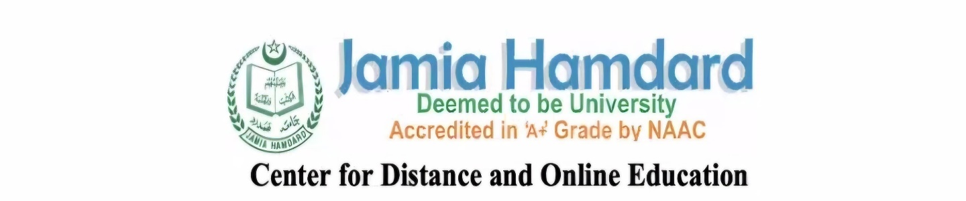
CERTIFICATE

On the basis of the declaration submitted by Mr. Vanshul Gupta, Enrollment No:-ODL/BCA/JULY-22/3266 a student of the Bachelor of Computer Applications (BCA) program, I hereby certify that the dissertation entitled " Clipperly – A Modern Barber Shop ", submitted to the Center for Distance and Online Education (CDOE), Jamia Hamdard, New Delhi, in partial fulfillment of the requirements for the award of the degree of Bachelor of Computer Applications (BCA), has been carried out by him under my supervision

Dr. Abdul Majid Farooqi Dr. Abdul Majid Farooqi

Program Coordinator BCA, (CDOE) (Supervisor)

DECLARATION

I, Mr. VANSHUL GUPTA a student of BACHELOR OF COMPUTER APPLICATIONS (BCA),(Enrolment No:- ODL/BCA/JULY-22/3266) hereby declare that the dissertation Entitled “Clipperly – A Modern Barber Shop" which is being submitted by me to the Centre for Distance and Online Education, Jamia Hamdard, New Delhi in partial fulfillment of the requirement for the award of the degree of Bachelor of Computer Application (BCA) in ODL mode is my original work and has not been submitted anywhere else for the award of any Degree, Diploma, Associateship, Fellowship or other similar title or recognition.

(Signature and name of the student)

________________

Date: - ______________

Place: - _______________

ACKNOWLEDGE

I would like to express my sincere gratitude to all those who supported me throughout the development of my project, "Clipperly – A Modern Barber Shop"
First and foremost, I extend my heartfelt thanks to my guide Dr. Abdul Majid Farooqi for their invaluable guidance, constructive feedback, and continuous encouragement, which were instrumental in the successful completion of this project.
I am also grateful to my institution, Jamia Hamdard, for providing me with the opportunity and resources to undertake this project as part of my academic curriculum. I wish special thanks to my family and friends, whose constant support and motivation helped me stay focused and committed during every stage of this project.
Lastly, I would like to acknowledge all the online resources, communities, and platforms that provided knowledge and technical assistance during the design and development of the Clipperly – A Modern Barber Shop website.
This project has been a great learning experience and has significantly enhanced my practical understanding of web development and e-commerce systems.

Student’s Signature

___________________

Date: -____________________

🟡 Index (Table of Contents)

Chapter No. | Title | Page No.
1. | Introduction | 1
2. | Objective | 2-3
3. | Software Requirements Specification (SRS) | 4-5
4. | System Analysis  – Existing System  – Proposed System | 6-7
5. | System Design  – Architecture & Structure  – Component & Page Layout | 8-10
6. | Frontend Implementation | 11-12
7. | Backend Implementation | 13-14
8. | Database Design | 15
9. | Admin Panel Functionality | 16-17
10. | Authentication | 18-19
11. | Testing & Debugging | 20-21
12. | Deployment | 22-23
13. | Conclusion | 24
14. | Project Screens – Clipperly Website | 25-64
15. | Future Scope | 65
16. | Bibliography | 66

🟡 List of Figures
Figure No. | Title | Page No.
Figure 1.1: | Clipperly Homepage with hero section, navigation bar, and dark/light toggle feature. | 25
Figure 1.2: | About section introducing the barbershop and its values. | 26
Figure 1.3: | Services section displaying grooming options with icons. | 27
Figure 1.4: | Testimonials section showing customer reviews and feedback layout. | 28
Figure 1.5: | Testimonials section showing customer reviews and feedback layout. | 29
Figure 1.6: | The Gallery section shows haircut styles and shop interiors. | 30
Figure 1.7: | Contact/Enquiry form for users to send queries to the shop. | 31
Figure 2.1: | About section introducing the barbershop and its values. | 32
Figure 2.2: | About section introducing the barbershop and its values. | 33
Figure 2.3: | About section introducing the barbershop and core values. | 34
Figure 2.4: | About section introducing the barbershop and Clipperly’s team. | 35
Figure 2.5: | About section introducing the barbershop and its footer. | 36
Figure 3.1: | Services section displaying grooming options with icons. | 37
Figure 3.2: | Services section displaying grooming options with icons. | 38
Figure 3.3: | The service section displays grooming options with icons and its footer. | 39
Figure 4.1: | The pricing table shows service names and corresponding costs. | 40
Figure 4.2: | The price table shows service names, corresponding costs and its footer. | 41
Figure 5.1: | The Barbers section presents team members with specialization details. | 42
Figure 5.2: | The barbers section presents team members with specialization details and its `footer. | 43
Figure 6.1: | The Gallery section shows haircut styles and shop interiors. | 44
Figure 6.2: | Gallery section showcasing haircut styles, shop interiors and its footer. | 45
Figure 7.1: | Testimonials section showing customer reviews and feedback layout. | 46
Figure 7.2: | Testimonials section showing customer reviews, feedback layout and its footer. | 47
Figure 8.1: | Contact/Enquiry form for users to send queries to the shop. | 48
Figure 8.2: | Contact/Enquiry form for users to send queries to the shop. | 49
Figure 8.3: | Contact/Enquiry form for users to send queries to the shop and its footer. | 50
Figure 9.1: | Enquiry management panel listing all user-submitted enquiries. | 51
Figure 9.2: | Enquiry management panel listing all user-submitted enquiries. | 52
Figure 9.3: | Enquiry management panel listing all user-submitted enquiries and its footer. | 53
Figure 10.1: | Admin dashboard overview with total enquiries, services, and testimonials. | 54
Figure 10.2: | Admin dashboard overview with total enquiries, services, testimonials with footer. | 55
Figure 10.3: | Admin dashboard overview with booking customers. | 56
Figure 10.4: | Admin dashboard overview with booking customers and footer. | 57
Figure 10.5: | Admin dashboard overview with management services. | 58
Figure 10.6: | Admin dashboard overview with management services and footer. | 59
Figure 10.7: | Add/Edit Service page with form and CRUD controls. | 60
Figure 10.8: | Add/Edit customer’s booking. | 61
Figure 10.9: | Add/Edit customer’s booking with footer. | 62
Figure 10.10: | Admin dashboard overview with service analytics. | 63
Figure 10.11: | Admin dashboard overview with service analytics and footer. | 64

Introduction
In the modern era, the digital presence of small and medium-scale businesses has become a critical factor in their growth and success. Among these, the grooming and salon industry is evolving rapidly with the help of technology. The demand for a professional and seamless user experience for booking grooming services online is increasing.
Clipperly – Barber Shop Website is a full-stack web application developed to cater to the needs of barbershops and salons by offering a digital platform where customers can view services, browse galleries, check availability, and book appointments. This project not only improves customer engagement but also simplifies the management process for barbershop owners through a dedicated admin panel.
This project is developed using modern technologies like Next.js, Tailwind CSS, Framer Motion, Node.js, Express, and MongoDB, with a clean and responsive user interface optimized for both mobile and desktop users.
The goal of this project is to provide an efficient, user-friendly, and scalable web solution to manage appointments, showcase services, and build an online identity for barbershop businesses.

2. Objective and Scope of the Project

2.1 Objective
The primary objective of Clipperly – Barber Shop Website is to develop a modern, responsive, and interactive web platform that meets the digital needs of a barbershop. The website aims to:
- Provide an intuitive frontend for customers to explore services, barbers, pricing, testimonials, and book appointments.
- Offer a powerful admin panel to manage services, customer inquiries, testimonials, and content dynamically.
- Deliver a clean and professional UI/UX with seamless transitions and responsive design for all devices.
- Enable backend functionality such as CRUD operations, authentication, and data storage using modern technologies.

2.2 Scope
The scope of this project includes:
- Frontend Website:
  - Landing page with hero section, services, about, gallery, barbers, testimonials, pricing, and contact.
  - Fully responsive design using Next.js and Tailwind CSS.
  - Smooth animations via Framer Motion and scroll animations using AOS (Animate on Scroll).
  - Integration of light/dark mode toggle.

- Backend Functionality:
  - API built with Node.js and Express.
  - Database operations with MongoDB.
  - Secure admin authentication and route protection.
- Admin Panel:
  - Dashboard overview with analytics cards.
  - Add/Edit/Delete operations for courses/services/testimonials.
  - Enquiry management with user details and delete feature.
- Additional Features:
  - Contact form with inquiry submission.
  - Newsletter subscription.
  - Scroll-to-top button and theme toggler.
This project ensures a smooth user journey and also provides robust tools to business owners to manage their barbershop digitally and efficiently.

3. Software Requirements Specification (SRS)

3.1 Functional Requirements
The system shall provide the following functionalities:
- Display homepage with navigation to sections like About, Services, Gallery, Barbers, Testimonials, Pricing, and Contact.
- Allow users to submit enquiries via a contact form.
- Enable admin login and authentication with secure credentials.
- Provide admin dashboard with control over:
  - Viewing submitted enquiries.
  - Adding, editing, or deleting services/courses/testimonials.
- Show testimonials dynamically from the database (for future implementation).
- Ensure smooth scroll-based and click-based navigation across the site.

3.2 Non-Functional Requirements
- The website must be responsive across all devices.
- The system must use modern UI/UX principles for a clean, fast experience.
- Admin routes must be secured through authentication (Firebase/Auth or JWT).
- Page transitions and UI interactions should be smooth and animated.
- The site must load within 3 seconds on an average network.
- The codebase must follow modular structure and be well-documented.

3.3 Software & Tools Used
Category | Tools / Frameworks
Frontend Framework | Next.js 14 (React-based SSR framework)
Styling & Design | Tailwind CSS
Animation | Framer Motion, AOS (Animate on Scroll)
Backend Framework | Node.js + Express.js (API creation)
Database | MongoDB (NoSQL)
Authentication | Firebase Auth / JWT
Version Control | Git & GitHub
Deployment (optional) | Vercel / Render / Firebase Hosting
Media Assets | Unsplash / Custom images

4. System Analysis

4.1 Existing System (Traditional Barbershop Approach)
In the traditional barbershop model:
- Customers usually walk in without prior booking.
- There is no digital platform to showcase services, prices, or barbers.
- Customer communication is mostly manual and offline.
- No enquiry tracking or testimonial collection is possible.
- Owners have limited reach to potential clients beyond their local area.

4.2 Problems with Existing System
- Lack of online visibility and branding.
- No way to manage or respond to customer enquiries efficiently.
- Customers cannot view services or pricing remotely.
- No system to collect feedback/testimonials.
- Difficult to manage admin tasks without digital automation.

4.3 Proposed System (Clipperly Website)
The proposed system — Clipperly – Barber Shop Website — is a fully functional web solution designed to overcome the limitations of the traditional model by:
- Providing a visually rich and mobile-friendly website.
- Showcasing services, pricing, and barbers with a modern layout.
- Integrating a contact/enquiry form to receive customer queries.
- Offering a secure admin panel to manage enquiries and content.
- Making the business searchable, accessible, and attractive to a wider audience.

4.4 Advantages of Proposed System
- 24×7 online presence and service showcase.
- Centralized management of content and enquiries.
- Professional brand image with animations and interactivity.
- Admin can easily monitor and update website content.
- Increased customer trust and engagement.

5. System Design

5.1 Architecture Overview
The system follows a modular, component-based architecture with a clear separation between the frontend (user-facing) and backend (admin/API) layers.
- Frontend: Built with Next.js for performance and SEO. Styled using Tailwind CSS, animations with Framer Motion & AOS.
- Backend: RESTful APIs built using Express.js with MongoDB for database operations.
- Admin Panel: Secured with authentication, dynamic routes and dashboard control.

5.2 Folder Structure

clipperly/
├── public/
│ └── assets/ # Static images and videos
├── src/
│ ├── app/
│ │ ├── admin/ # Admin routes
│ │ ├── enquiry/ # Enquiry form
│ │ └── page.tsx # Main landing page
│ ├── components/ # Reusable UI components
│ ├── firebase/ # Firebase configuration
│ ├── lib/ # Utility functions
│ ├── styles/ # Global styles and themes
│ └── api/ # API routes (optional)
├── .env # Environment variables
├── tailwind.config.ts # Tailwind configuration
├── tsconfig.json # TypeScript config
└── package.json # Dependencies

5.3 Page & Component Layout

🖥️ Main Website Pages:
Page | Purpose
Home | Hero section, branding, call-to-action
About | Shop story and identity
Services | List of grooming services offered
Pricing | Table of service charges
Gallery | Images of shop, tools, styles
Barbers | Profiles of barbers
Testimonials | Reviews from customers
Contact / Enquiry | Contact form, location info

🔐 Admin Panel Pages:
Page | Function
Login | Firebase/Auth-secured login
Dashboard | Overview cards (total enquiries, etc.)
Enquiries | List of all submitted enquiries
Courses/Services | Manage listed services (add/edit/delete)
Testimonials | Display and approve client feedback

6. Frontend Implementation

The frontend of Clipperly – Barber Shop Website was developed using Next.js 14, a powerful React framework that supports server-side rendering, routing, and performance optimization. The UI is styled using Tailwind CSS, a utility-first CSS framework, making the design modular and highly responsive.

6.1 Technologies Used
Tool/Library | Purpose
Next.js | Frontend framework & routing
Tailwind CSS | Styling and layout
TypeScript | Static typing for better maintainability
Framer Motion | Animations and transitions
AOS (Animate on Scroll) | Scroll-based reveal animations
React Icons | Vector icons for UI

6.2 Key Frontend Features
✅ 1. Home Page
- Hero section with branding and call-to-action
- About the barbershop section
- Smooth scroll to other sections
- Theme toggle (light/dark)
✅ 2. Services Section
- Display of services with icons and brief descriptions
- Well-organized grid structure

✅ 3. Pricing Page
- Responsive table showing service names and prices
- Clean layout with alternate row shading
✅ 4. Gallery Section
- Responsive image grid with animations
- Showcasing interior, equipment, and haircut styles
✅ 5. Barbers Section
- Cards showing barber images, names, and specialities
- Animated reveal on scroll
✅ 6. Testimonials
- Static (or dynamic in future) customer reviews
- Card-based layout
✅ 7. Contact / Enquiry Page
- Full contact form: Name, Email, Phone, Message
- Input validation and feedback
- Submit button linked to backend API

6.3 Responsive Design
- All pages are mobile, tablet, and desktop responsive.
- Implemented using Tailwind CSS breakpoints.
- Tested manually on multiple screen sizes.

6.4 Animations
- Smooth page transitions with Framer Motion
- Section-by-section reveal using AOS
- Hover effects on cards, buttons, images
7. Backend Implementation

The backend of Clipperly – Barber Shop Website is designed using Node.js and Express.js to handle API routes, perform CRUD operations, and interact with a MongoDB database. It supports secure admin control and dynamic content management.

7.1 Technologies Used
Tool / Tech | Purpose
Node.js | Server runtime environment
Express.js | Web framework to create RESTful APIs
MongoDB | NoSQL database for storing enquiries, etc.
Mongoose | ODM for MongoDB schema & queries
Firebase Auth / JWT | Authentication for Admin access
CORS, dotenv | Security and environment management

7.2 API Routes Overview
Route | Method | Description
/api/enquiry | POST | Submit contact form enquiry
/api/enquiry | GET | Get all enquiries (admin only)
/api/enquiry/:id | DELETE | Delete specific enquiry (admin only)
/api/testimonials | GET | Fetch testimonials
/api/testimonials | POST | Add new testimonial (admin only)
/api/courses | CRUD | Manage services (admin panel)

7.3 Enquiry Submission Flow
- User submits enquiry from contact form.
- Frontend sends a POST request to /api/enquiry.
- Backend validates and stores the enquiry in MongoDB.
- Admin retrieves all enquiries via GET and can delete any with DELETE.

7.4 Security & Authentication
- Admin routes are protected using Firebase Authentication or JWT tokens.
- Unauthorized users are redirected to the login page.
- Backend API checks for authentication headers before performing actions.

7.5 Backend Challenges Handled
- Form validation and error handling
- Route protection using middleware
- Secure API connection with MongoDB Atlas / localhost
- Handling CORS for cross-origin requests

8. Database Design & Schema

Clipperly – Barber Shop Website uses MongoDB, a flexible NoSQL document-based database, to store and retrieve data for enquiries, testimonials, and (optionally) services or courses. The data is stored in collections (like tables in relational databases), and each entry is a document in JSON-like format.

8.1 Collections Overview
Collection Name | Purpose
enquiries | Stores customer contact form submissions
testimonials | Stores customer feedback/testimonials
services / courses | Stores service details (admin control)

8.2 Sample Schema Definitions (Mongoose)
📄 Enquiry Schema
📄 Testimonial Schema
📄 Service/Course Schema

8.3 Relationships & Design Logic
- Each enquiry is standalone and does not need relations to other collections.
- Testimonials may later link to user accounts (if user system is added).
- Services can be filtered by categories (e.g., Haircut, Shave, Facial) in future iterations.

8.4 Database Deployment (Optional)
- Can be hosted on MongoDB Atlas for production.
- During development, localhost MongoDB is used with mongoose.connect().
9. Admin Panel Functionality

The Clipperly Admin Panel empowers the website owner or admin to manage content dynamically without touching the codebase. It provides access to important data like enquiries, testimonials, and services, with a user-friendly dashboard layout.

9.1 Admin Login System
- Admin accesses login page via /admin.
- Secure login using Firebase Authentication or JWT.
- On successful login, admin is redirected to the dashboard.
- Unauthorized users cannot access dashboard routes.

9.2 Dashboard Overview
The dashboard is the landing screen after login, showing summary statistics via dashboard cards such as:
- Total Enquiries
- Total Services
- Total Testimonials (optional)
- System Status or Greeting
Cards are styled with Tailwind and animated with Framer Motion.

9.3 Enquiry Management
Feature | Function
View All Enquiries | Table with user name, email, phone, message
Delete Enquiry | Remove individual enquiry from database
Live Updates | Optionally fetch data dynamically (if used)

9.4 Service Management
Feature | Function
Add New Service | Input form with title, price, image
Edit Existing Service | Modify service details
Delete Service | Remove service from the database
Image Upload | Upload and preview (if integrated)

9.5 Testimonials Management (Optional/Future Scope)
- Approve/Disapprove user-submitted feedback.
- Display approved testimonials on frontend dynamically.

9.6 Route Structure
URL | Description
/admin/login | Admin authentication
/admin/dashboard | Overview screen
/admin/enquiries | View/delete enquiries
/admin/services | CRUD for services
/admin/testimonials | View/add testimonials

The admin panel ensures that the Clipperly website is scalable and manageable, turning a static website into a dynamic business tool.

10. Authentication & Security

Security is a critical component of any modern web application, especially for admin dashboards and user-submitted content. The Clipperly project ensures that all sensitive operations are protected and secure, preventing unauthorized access and misuse.

10.1 Authentication Flow
- Admin Login is required to access the dashboard.
- Firebase Authentication (or JWT) is used to verify the admin’s identity.
- After login, a secure token/session is stored (in localStorage or cookies).
- Protected routes like /admin/dashboard, /admin/enquiries, etc., check authentication before rendering content.

10.2 Protected Routes
- Pages behind login are accessible only if the user is authenticated.
- If a non-authenticated user tries to access admin routes, they are redirected to the login page.

10.3 Backend Security (API)
- API requests (GET, POST, DELETE) check for a valid token before allowing changes.
- CORS policy is set to allow requests only from trusted origins.
- Environment variables (.env) store sensitive keys like DB credentials and auth secrets.

10.4 Form Validation & Sanitization
- User input from contact forms is validated on both frontend and backend.
- Prevents SQL/NoSQL injection or XSS attacks.
- Required fields like name, email, and message are validated using regex or schema-based rules.

10.5 Error Handling
- Clear and user-friendly error messages.
- 404 or unauthorized access pages for broken or restricted routes.

Clipping unauthorized access, Clipperly ensures that only authenticated users can interact with protected content, maintaining integrity and security across the system.

11. Testing & Debugging

Thorough testing and debugging ensure that the Clipperly website is reliable, stable, and performs well across different environments. Both manual testing and tool-based auditing were used.

11.1 Manual Testing
The site was tested manually on:
Device/Platform | Status
Desktop (Chrome, Edge) | ✅ Responsive & functional
Mobile (Android/iOS browsers) | ✅ Optimized layout, animations
Tablet | ✅ Layout adapts perfectly
Slow/Low Networks | ✅ Loads within 3–5 seconds
Manual tests checked for:
- Broken links
- Form input validations
- Responsive layout at various screen sizes
- Scroll animations & transitions
- Dashboard CRUD functionality

11.2 Lighthouse Testing (Google Chrome)
Lighthouse, an open-source tool by Google, was used to test:
Metric | Score
Performance | 90+
Accessibility | 95+
Best Practices | 100
SEO | 90+

11.3 Debugging Techniques
- Used React DevTools to inspect components and state.
- Checked console logs for API errors and warnings.
- Handled edge cases like:
  - Submitting empty enquiry forms
  - Trying to access protected admin pages without login
  - Deleting already deleted content
- Monitored network calls using browser’s developer tools.

11.4 Version Control
All development was done using Git, ensuring:
- Safe rollbacks
- Feature-based commits
- Collaborative readiness (if needed)

With rigorous testing, the Clipperly website ensures a smooth and error-free experience for both users and administrators.

12. Deployment

Deployment is the process of publishing a web application to the internet so it can be accessed by users. The Clipperly website was designed to be deployment-ready, whether on cloud platforms or local servers.

12.1 Deployment Platforms (Optional/Planned)
Platform | Purpose
Vercel | Frontend hosting (Next.js optimized)
Render / Railway | Node.js + MongoDB backend deployment
Firebase Hosting | Full project hosting (if configured)
Note: In your current setup, the project is hosted and tested locally on http://localhost:3000

12.2 Steps to Deploy Frontend (e.g., on Vercel)
- Push the project to a GitHub repository.
- Connect Vercel with GitHub.
- Import the repository and choose the root folder (/).
- Set environment variables (e.g., for Firebase or MongoDB).
- Click “Deploy” and wait for Vercel to build the app.

12.3 Steps to Deploy Backend (e.g., Render)
- Push your backend code to a separate GitHub repository.
- Go to Render.com > Create new Web Service.
- Connect GitHub and select your backend repo.
- Add environment variables:
  - MONGO_URI
  - JWT_SECRET (if using JWT)
- Choose Node.js as the environment.
- Deploy.

12.4 Production Considerations
- Enable HTTPS.
- Set up custom domains if needed.
- Monitor app performance via analytics or Vercel’s dashboard.
- Enable caching and compress static files.

With deployment in place, Clipperly becomes fully accessible and scalable, ready to serve real users in a live production environment.

13. Conclusion

Clipperly – Barber Shop Website is a fully functional, full-stack web application designed with modern technologies to enhance the digital presence of barbershops. From a beautifully crafted user interface to a powerful admin backend, Clipperly enables both customers and shop owners to interact in a professional, organized, and efficient manner.
The project demonstrates real-world application of frontend and backend web development principles, showcasing:
- Responsive design using Next.js and Tailwind CSS
- Scroll and animation effects using AOS and Framer Motion
- Backend APIs and database operations using Node.js, Express, and MongoDB
- Secure admin panel with authentication and dashboard functionality
This project serves not only as a live business tool but also as a strong portfolio piece reflecting full-stack development skills. With future upgrades, it could include user login, appointment booking, real-time messaging, and payment integration.

14. Project Screens – Clipperly Website:
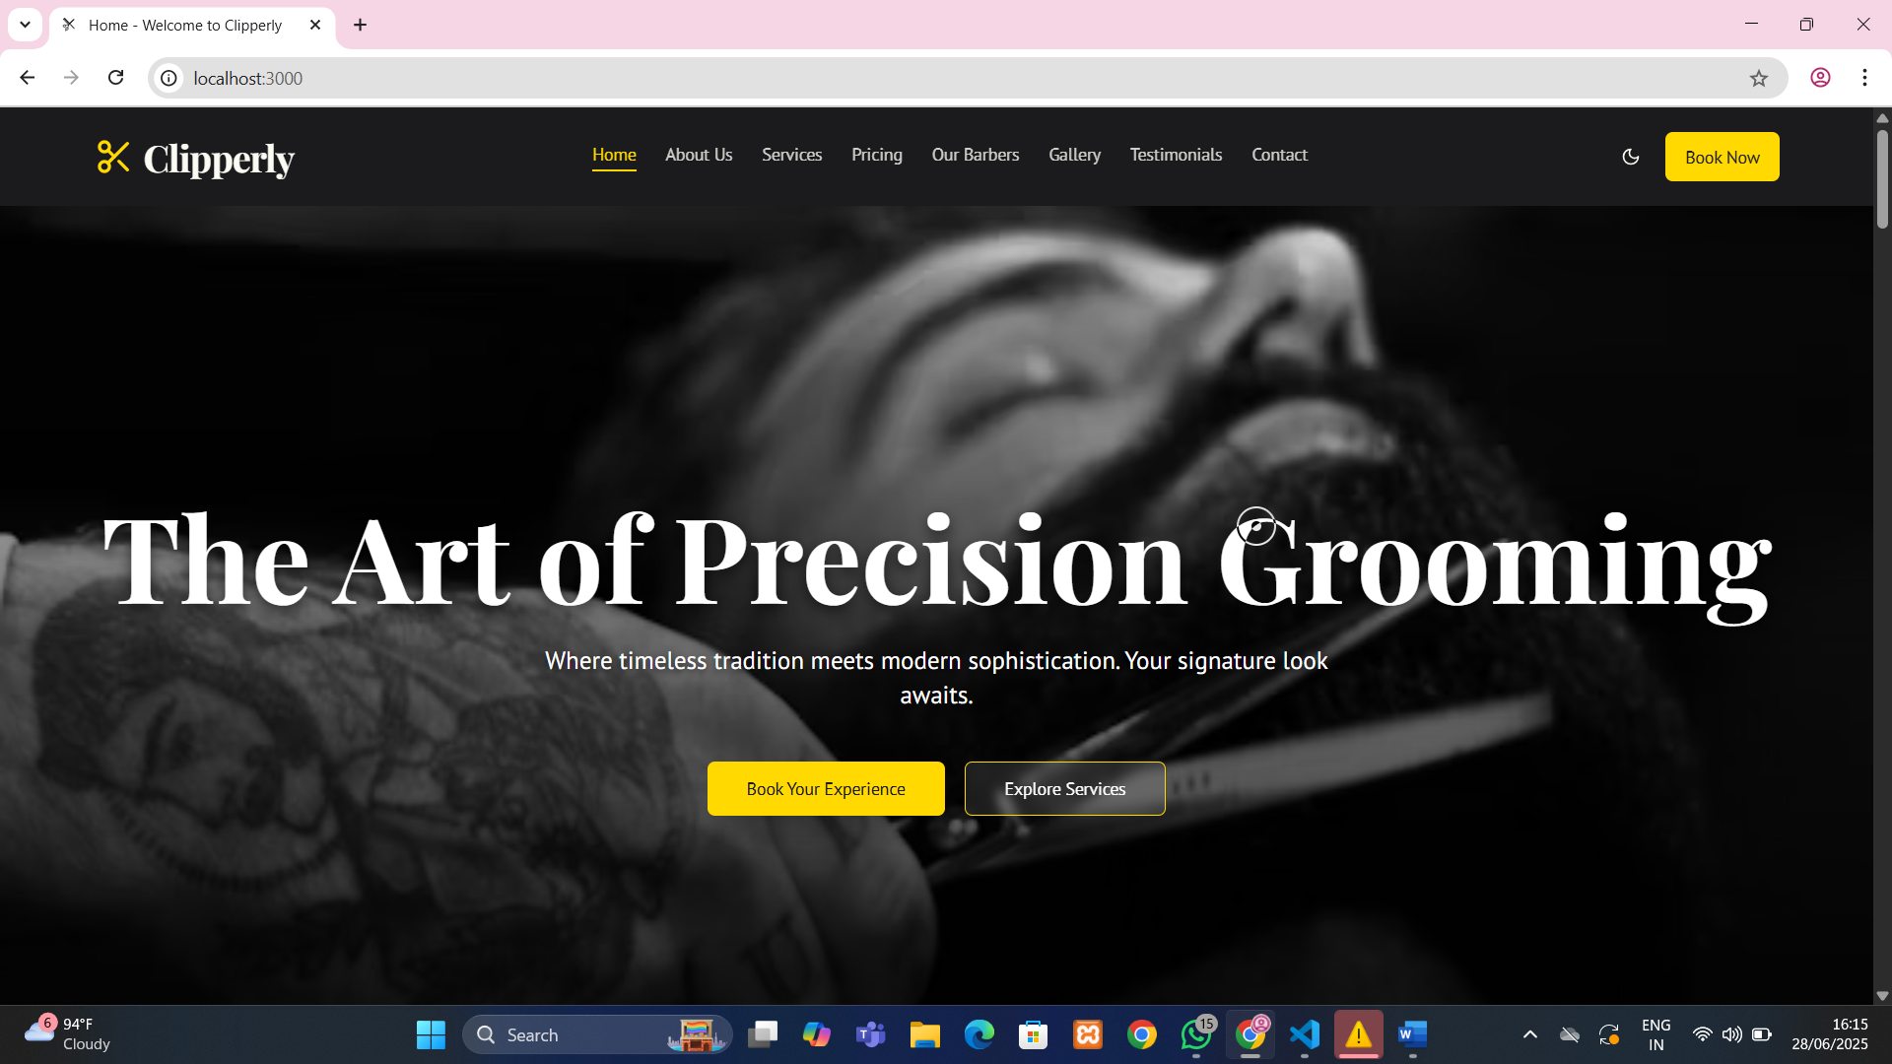

Figure 1.1: Clipperly Homepage with hero section, navigation bar, and dark/light toggle feature.

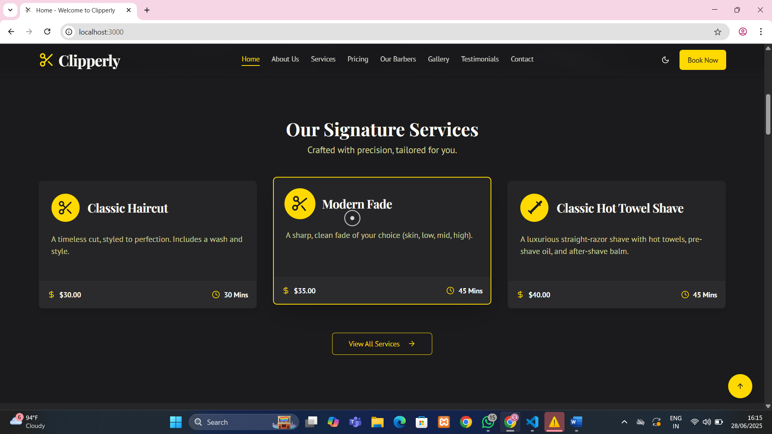

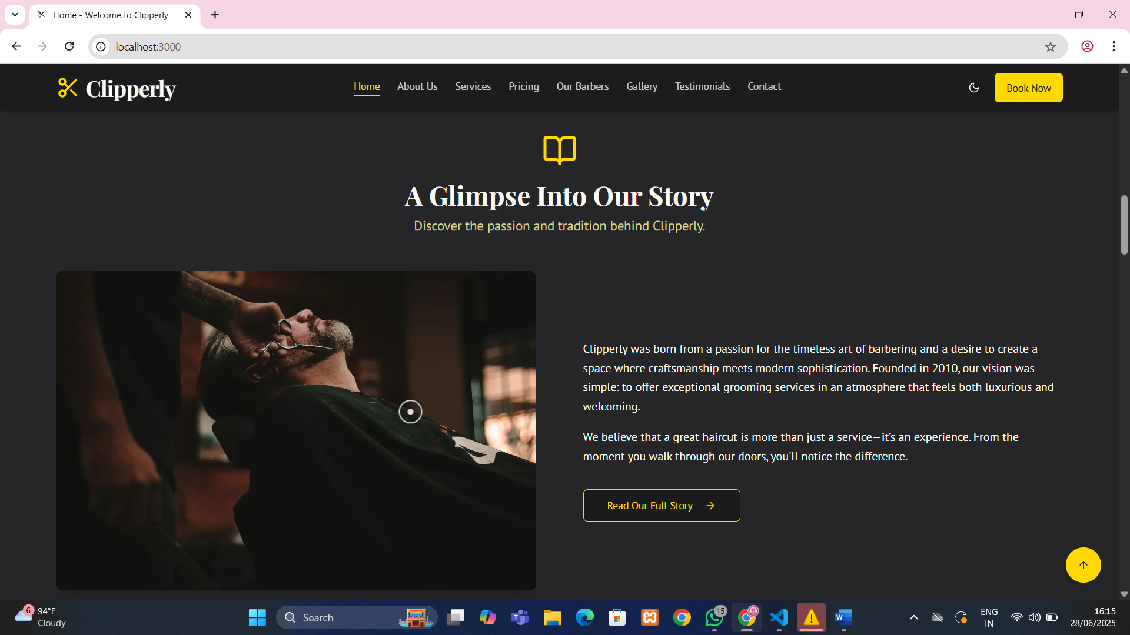
Figure 1.2: About section introducing the barbershop and its values.

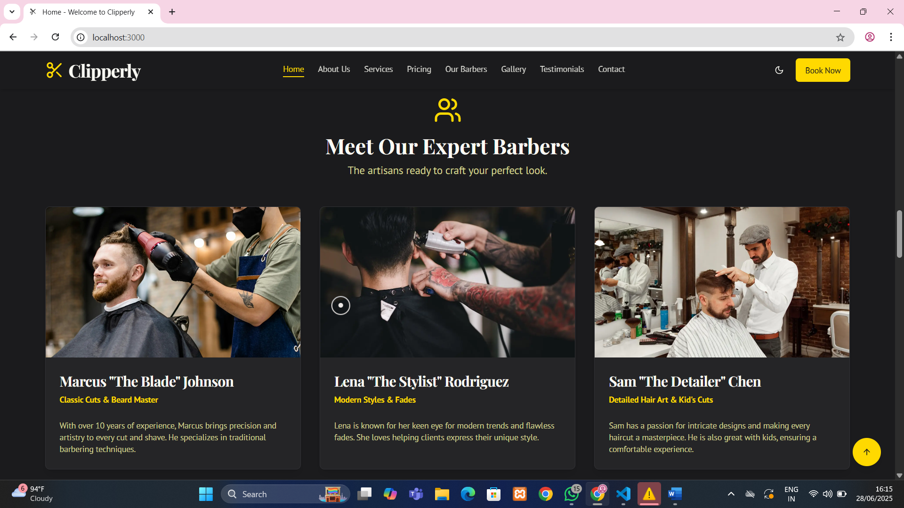

Figure 1.3: Services section displaying grooming options with icons.

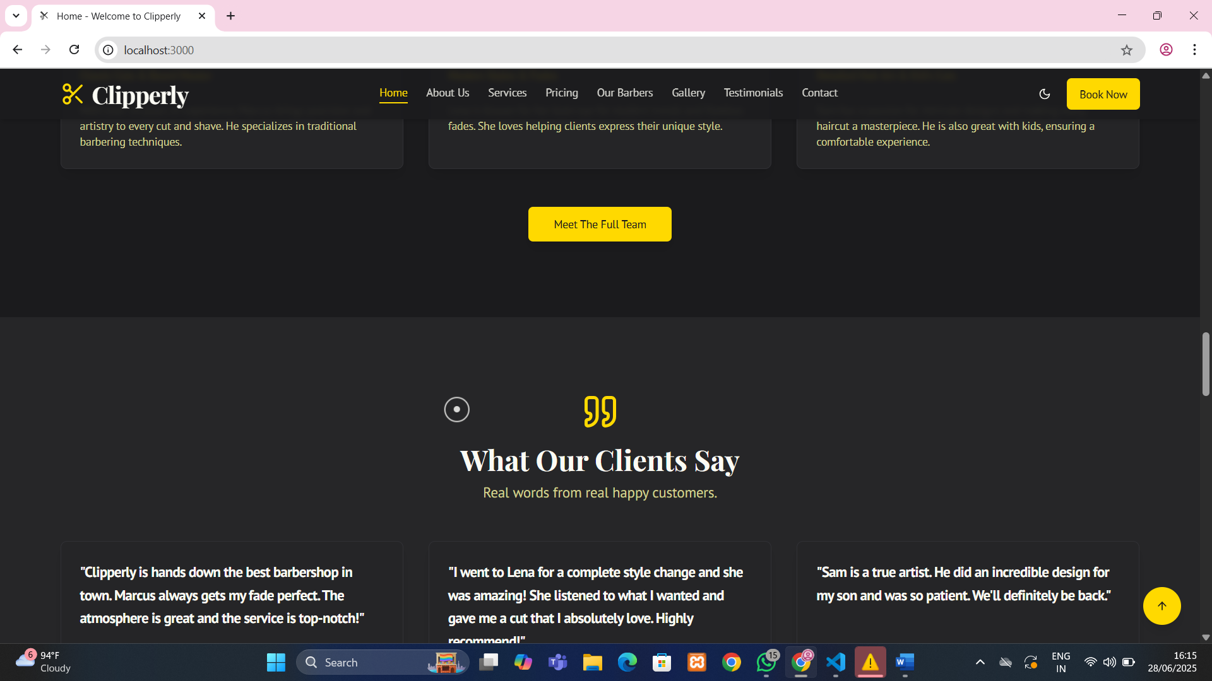

Figure 1.4: Testimonials section showing customer reviews and feedback layout.

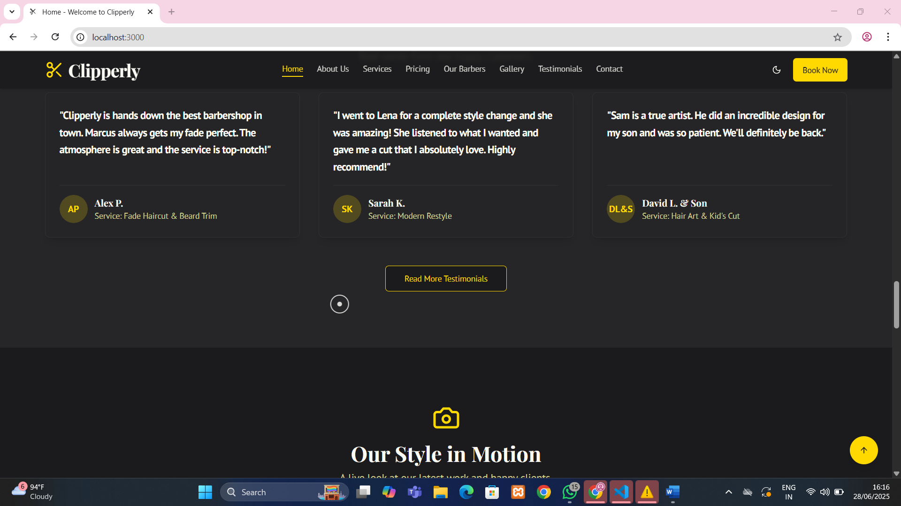

Figure 1.5: Testimonials section showing customer reviews and feedback layout.

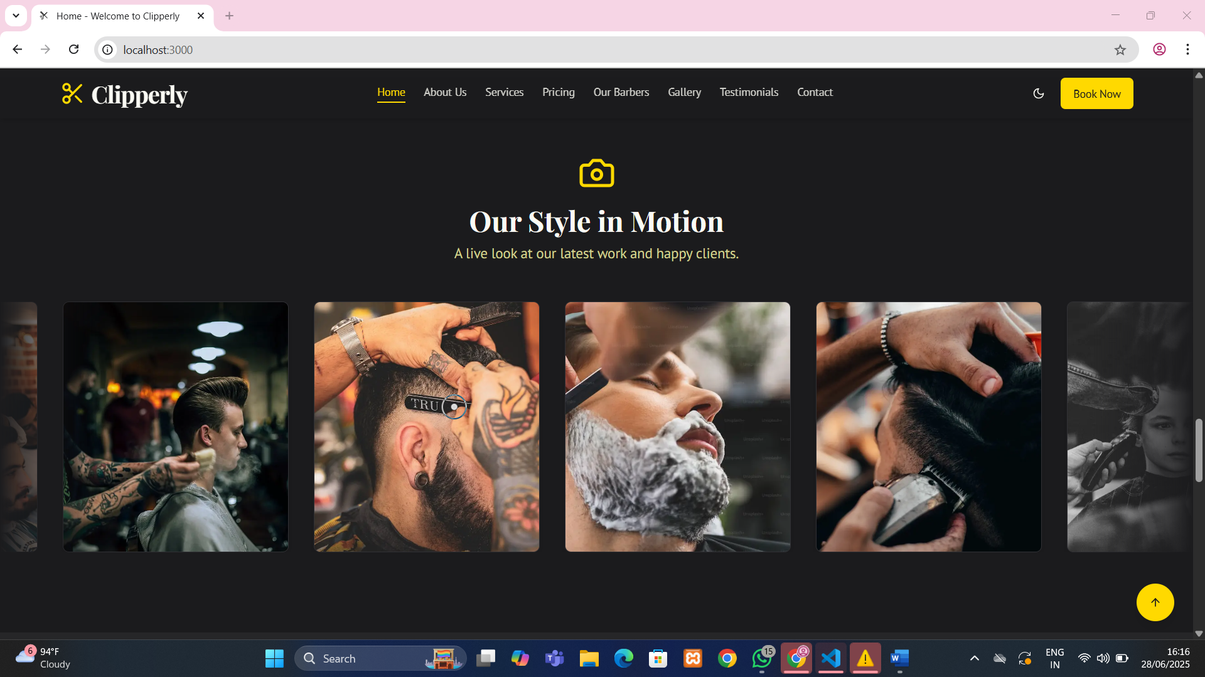

Figure 1.6: Gallery section showcasing haircut styles and shop interiors.

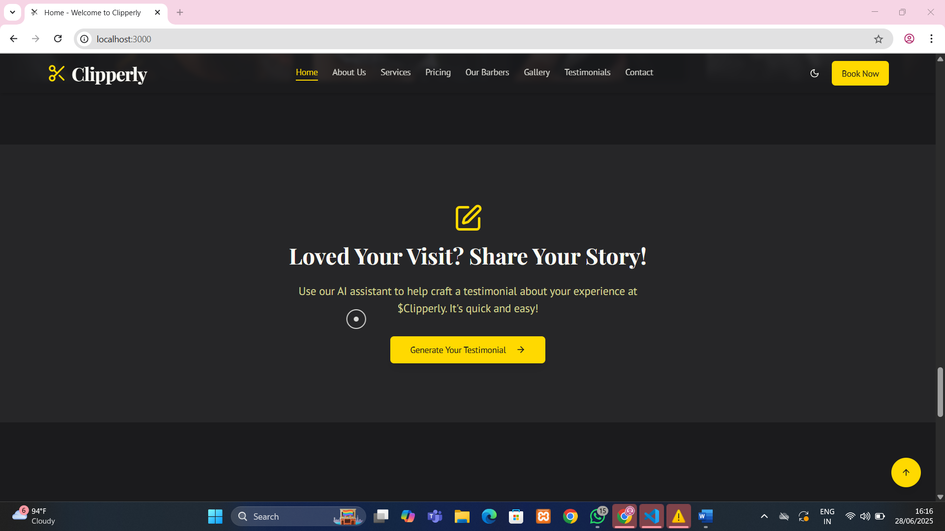

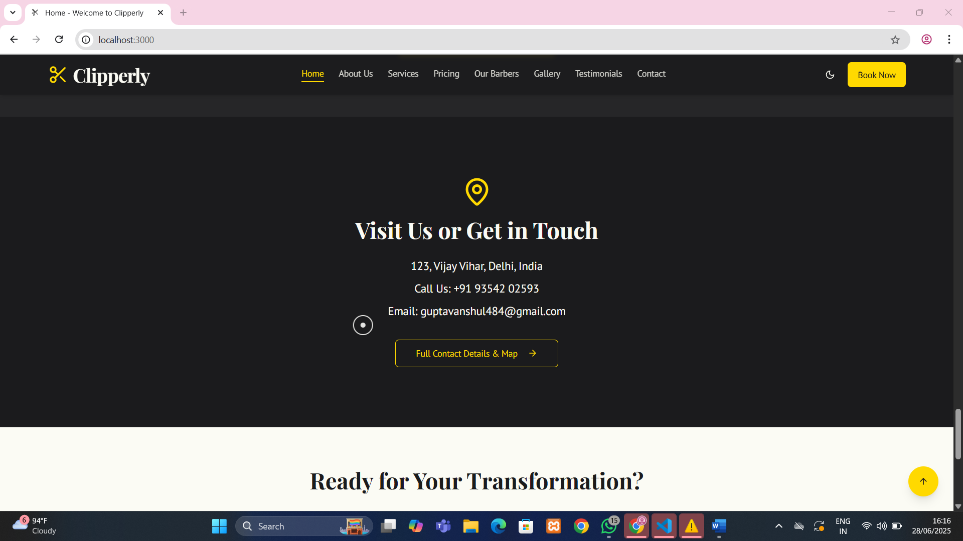
Figure 1.7: Contact/Enquiry form for users to send queries to the shop.

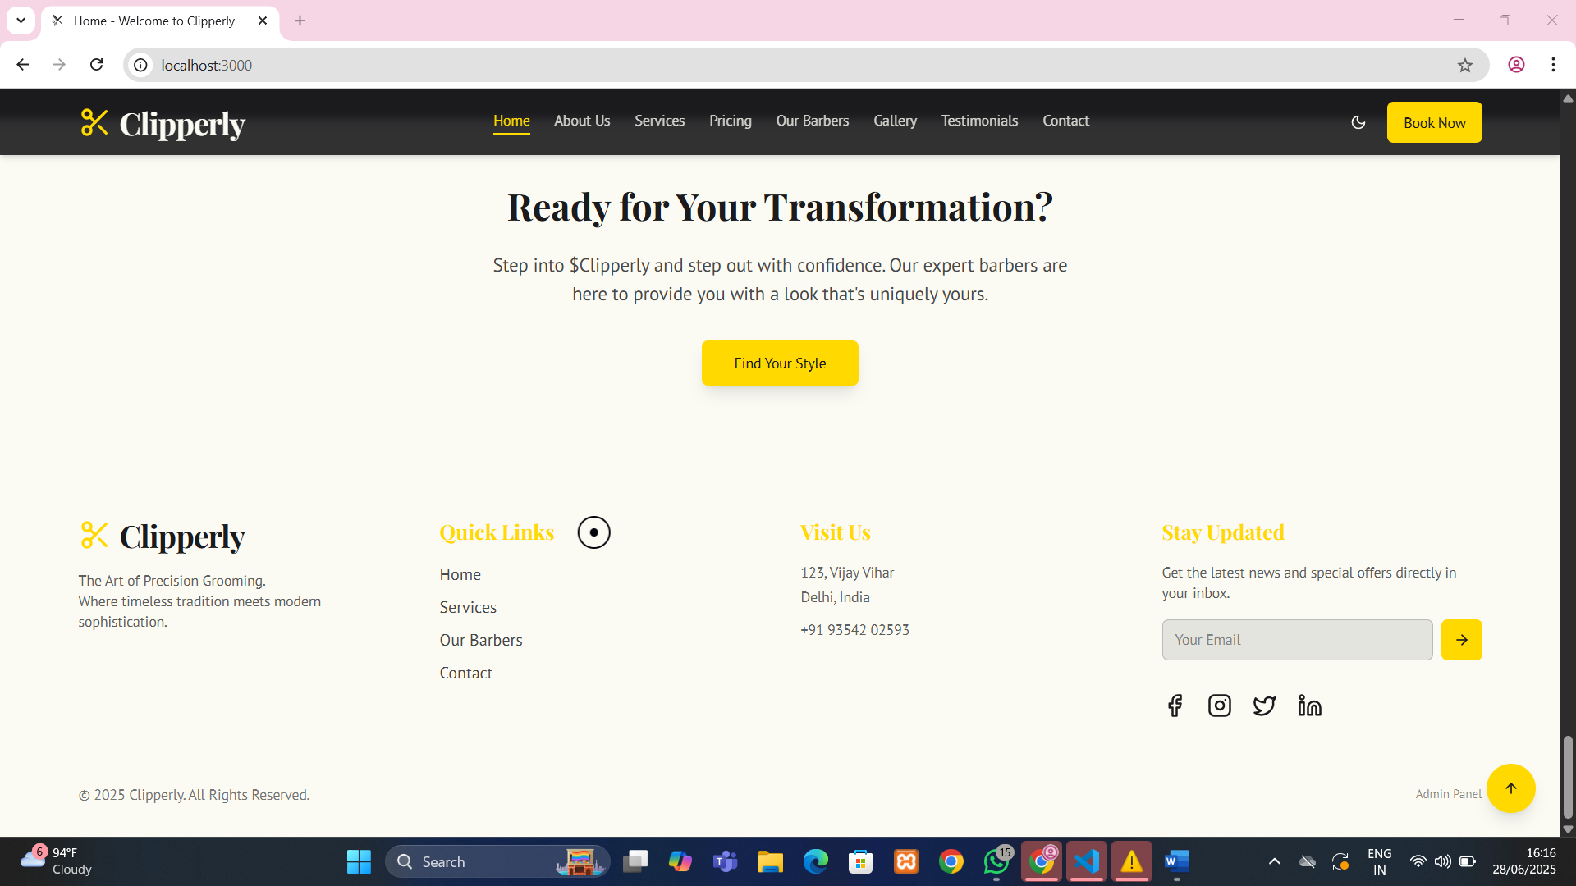

Figure 2.1: About section introducing the barbershop and its values.

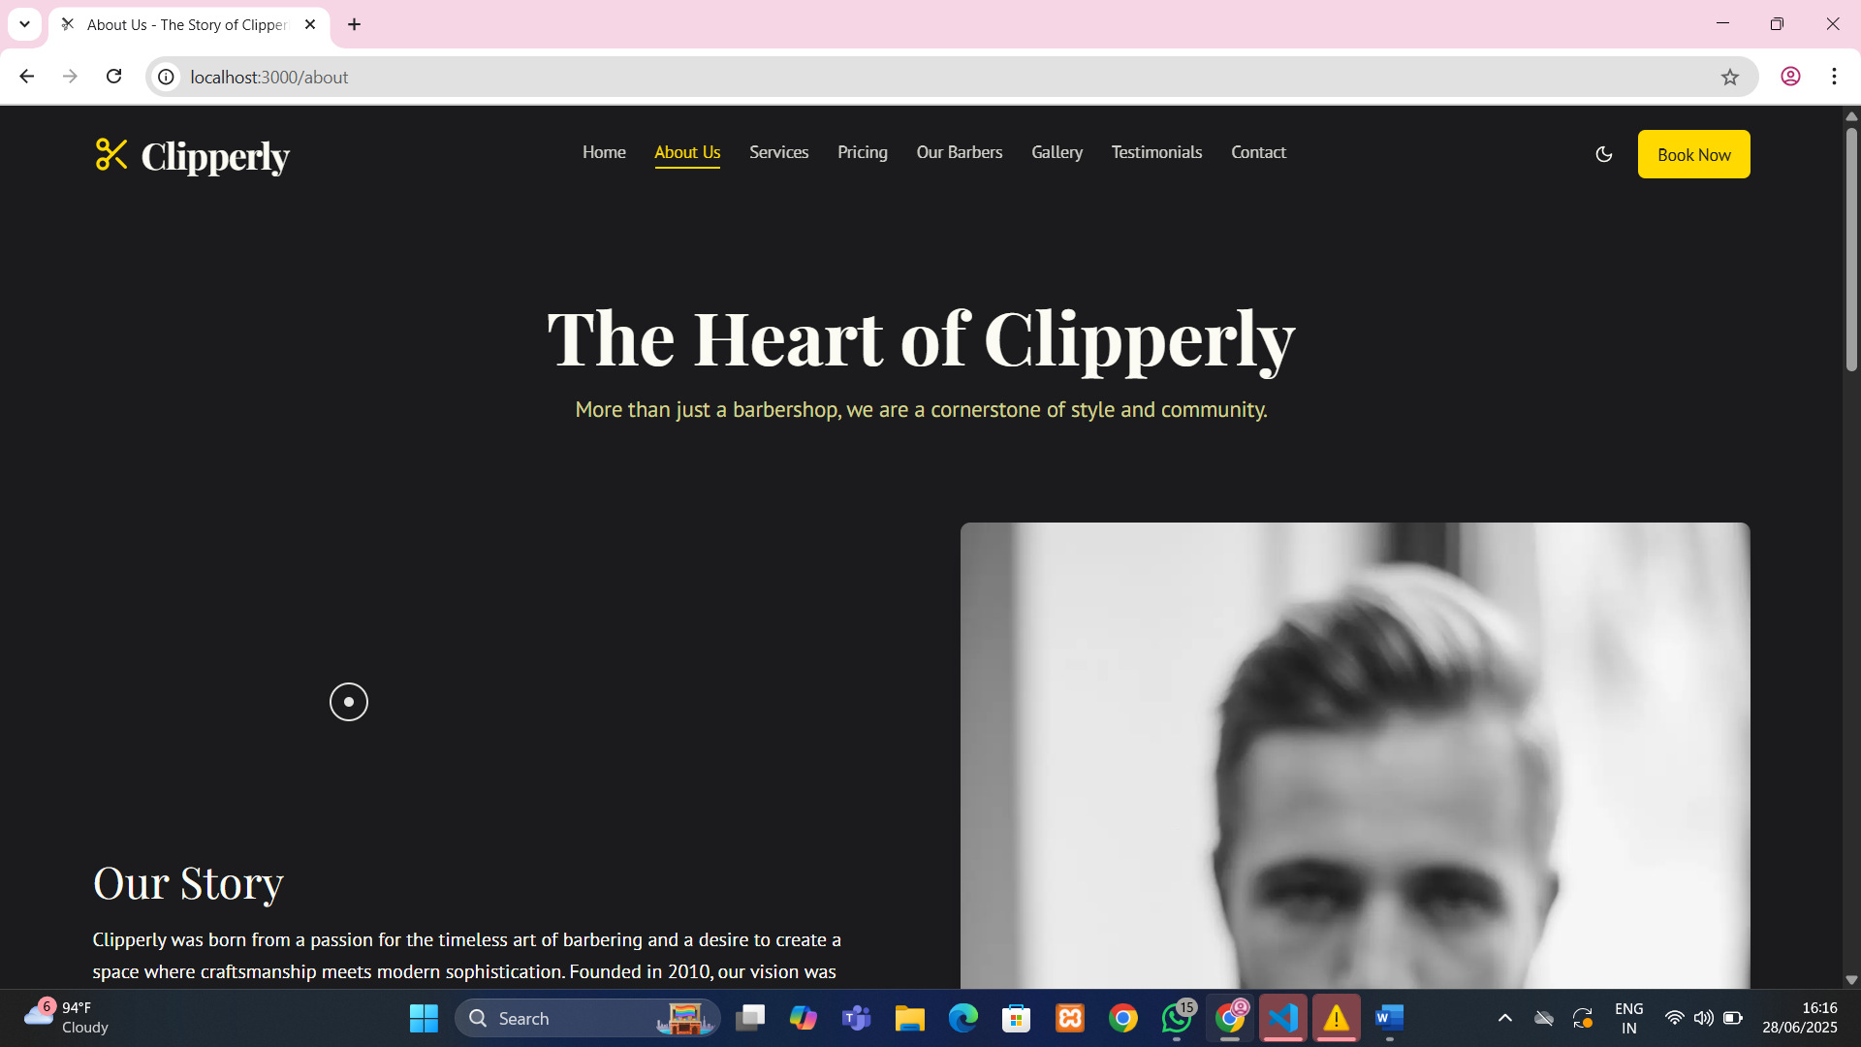

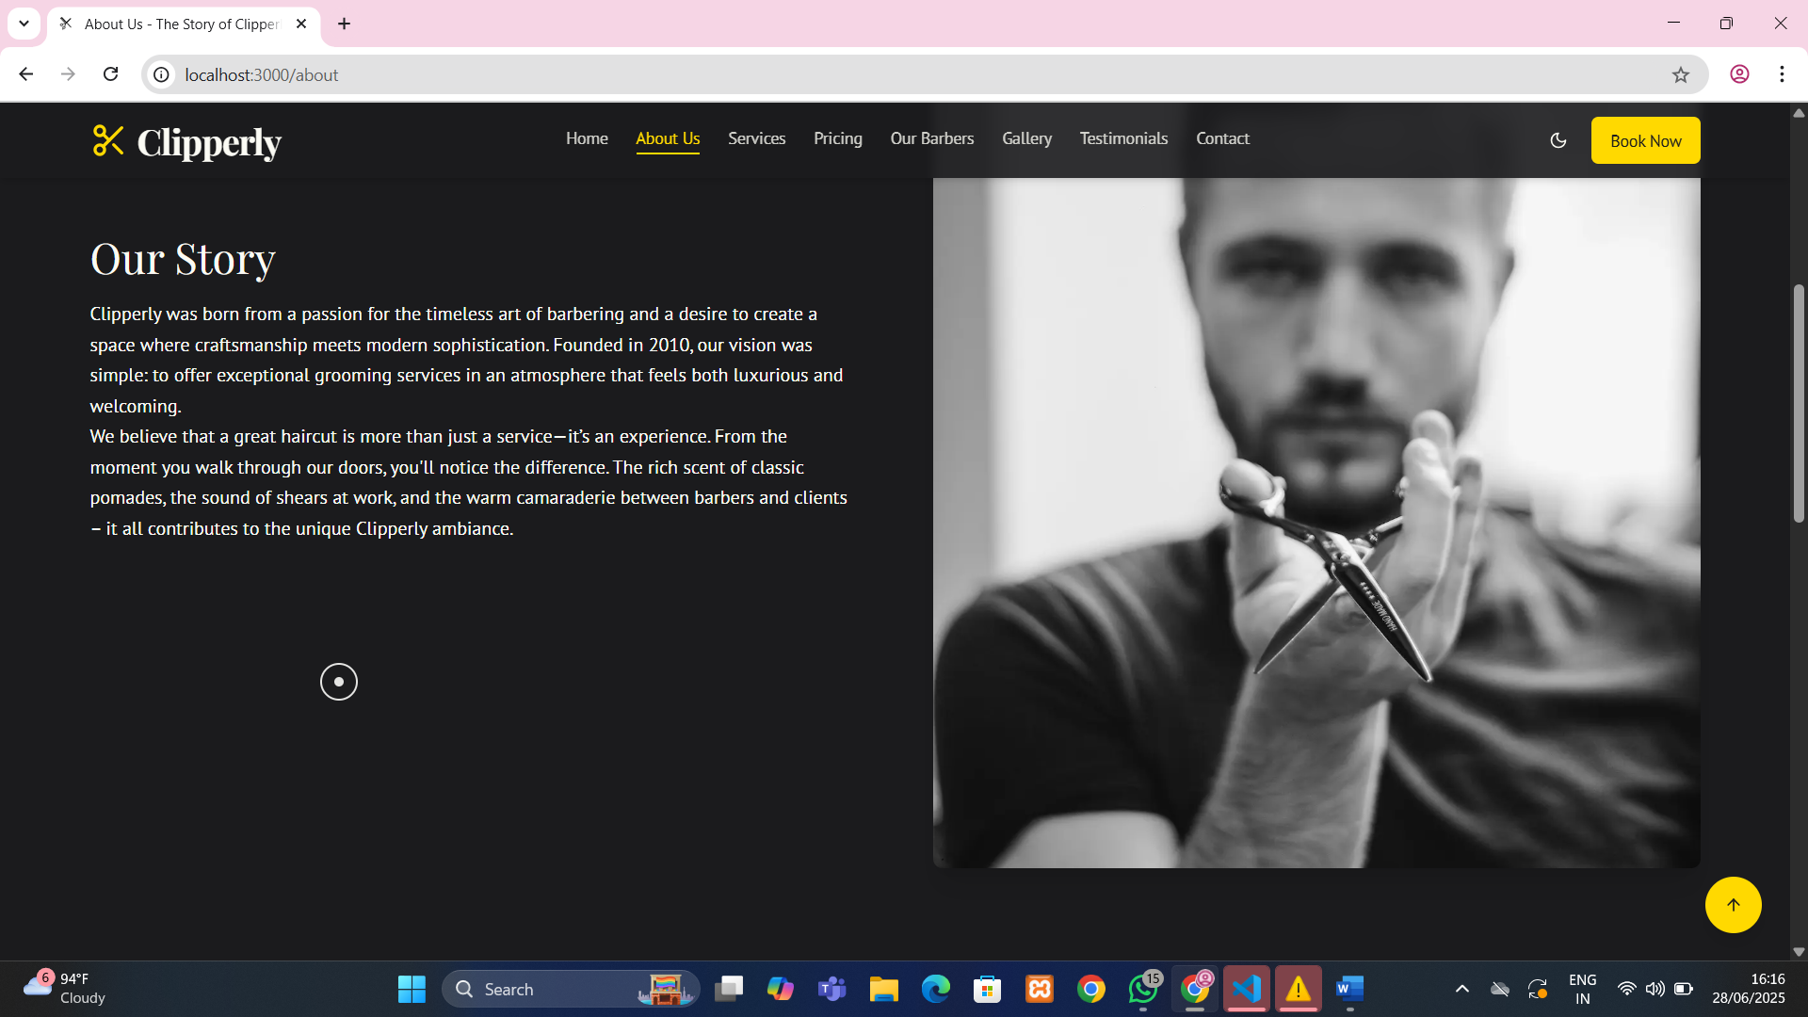
Figure 2.2: About section introducing the barbershop and its values.

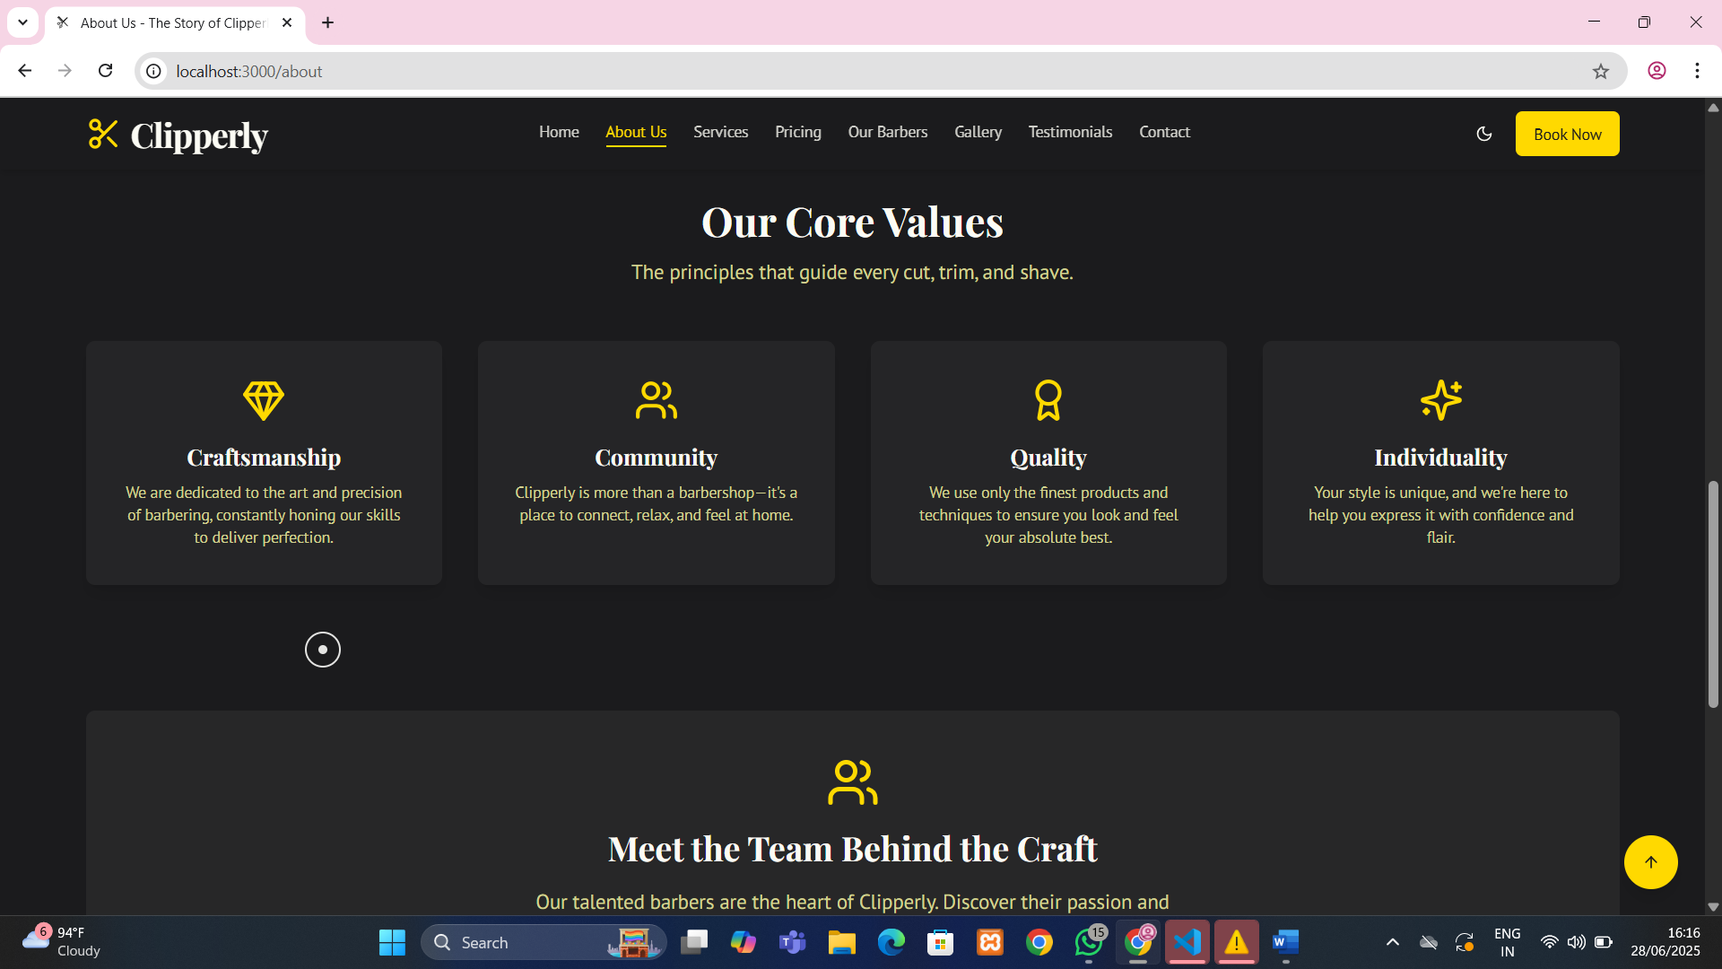
Figure 2.3: About section introducing the barbershop and core values.

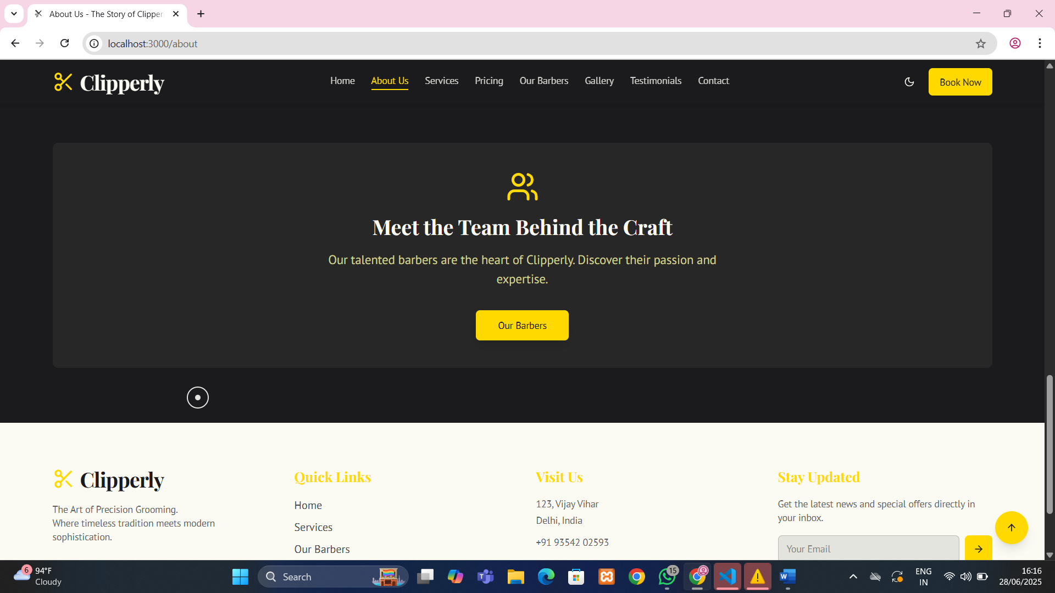

Figure 2.4: About section introducing the barbershop and Clipperly’s team.

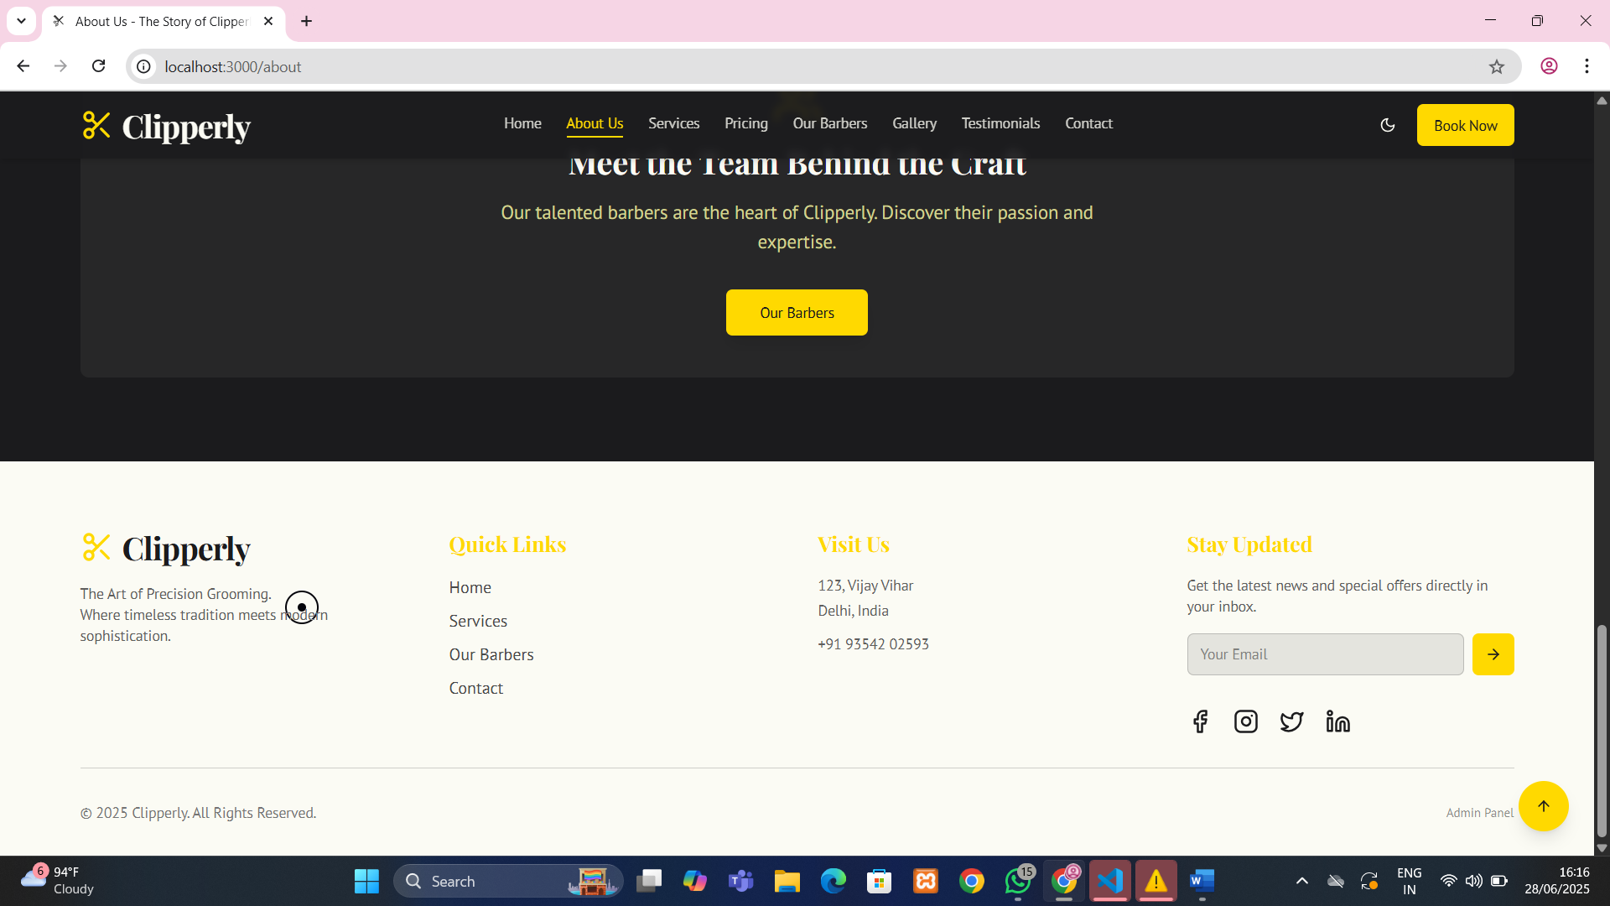
Figure 2.5: About section introducing the barbershop and its footer.

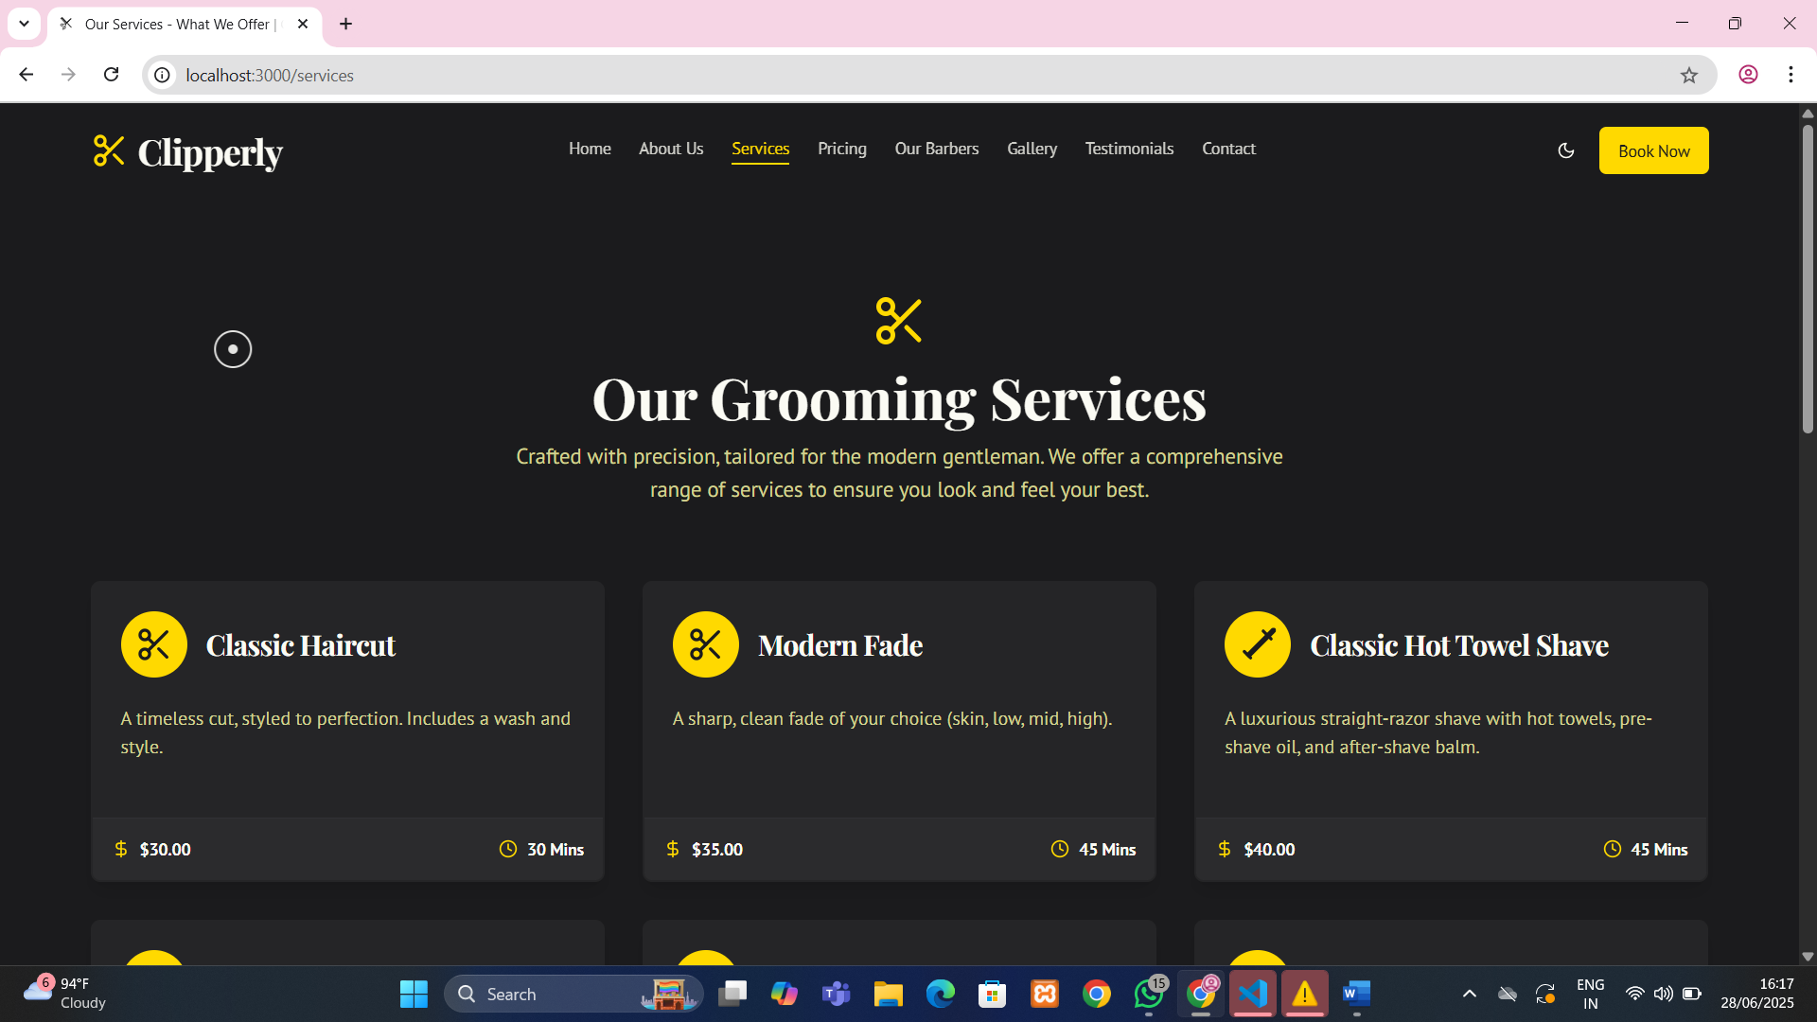

Figure 3.1: Services section displaying grooming options with icons.

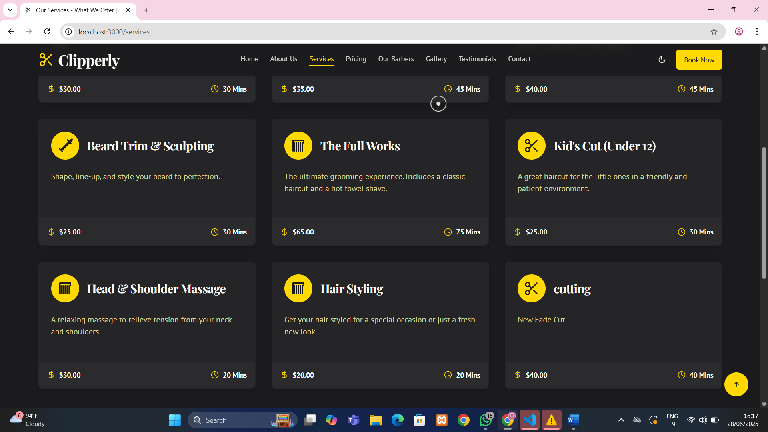

Figure 3.2: Services section displaying grooming options with icons.

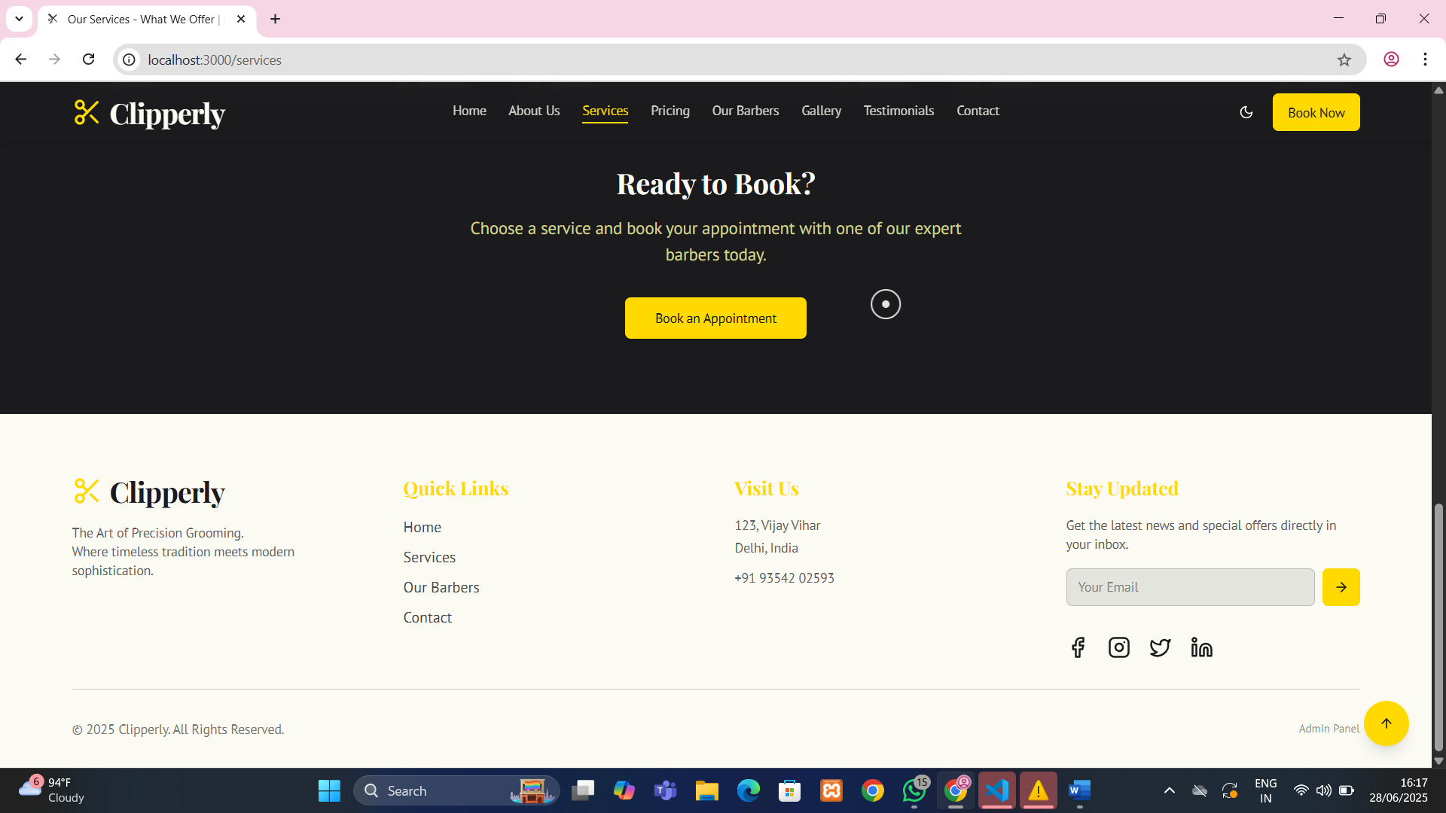

Figure 3.3: Services section displaying grooming options with icons and its footer.

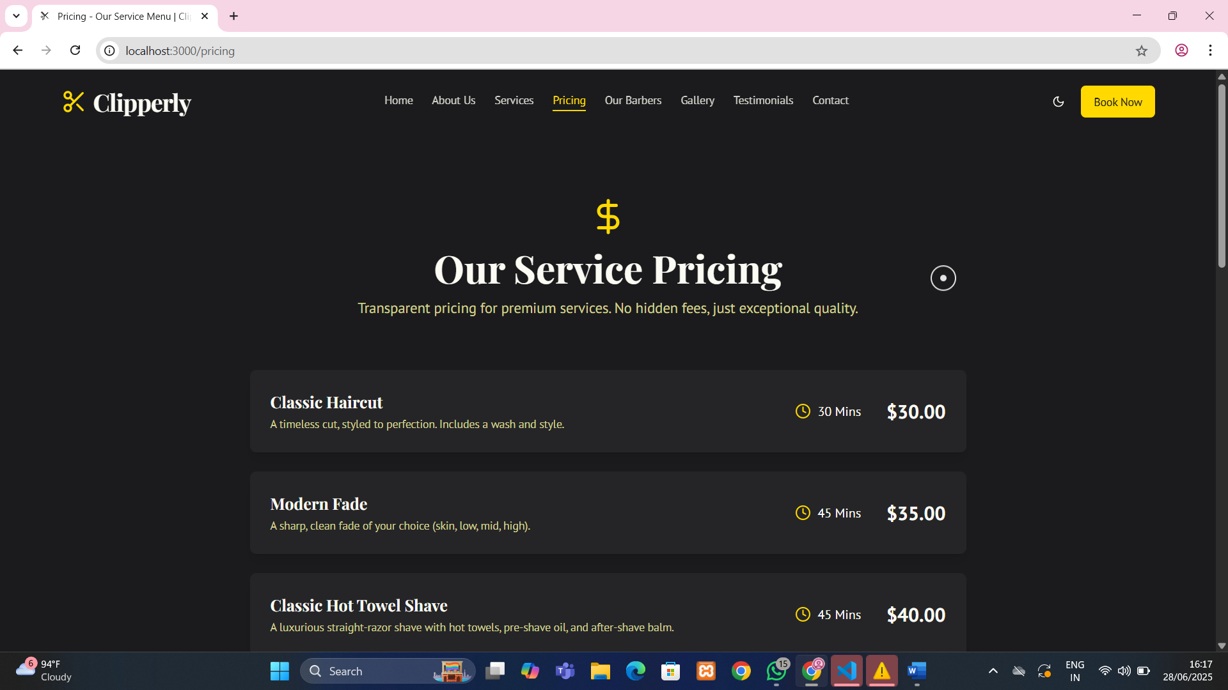

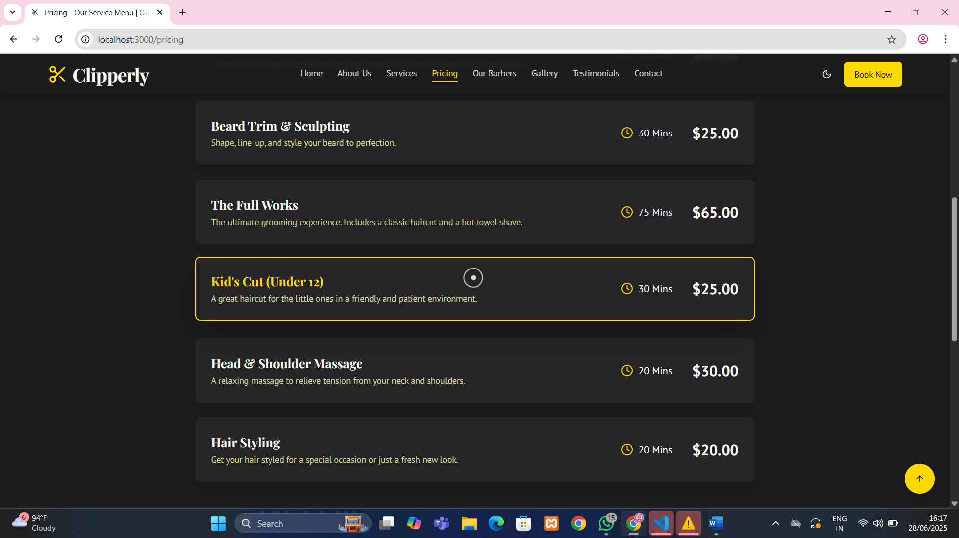

Figure 4.1: Pricing table showing service names and corresponding costs.

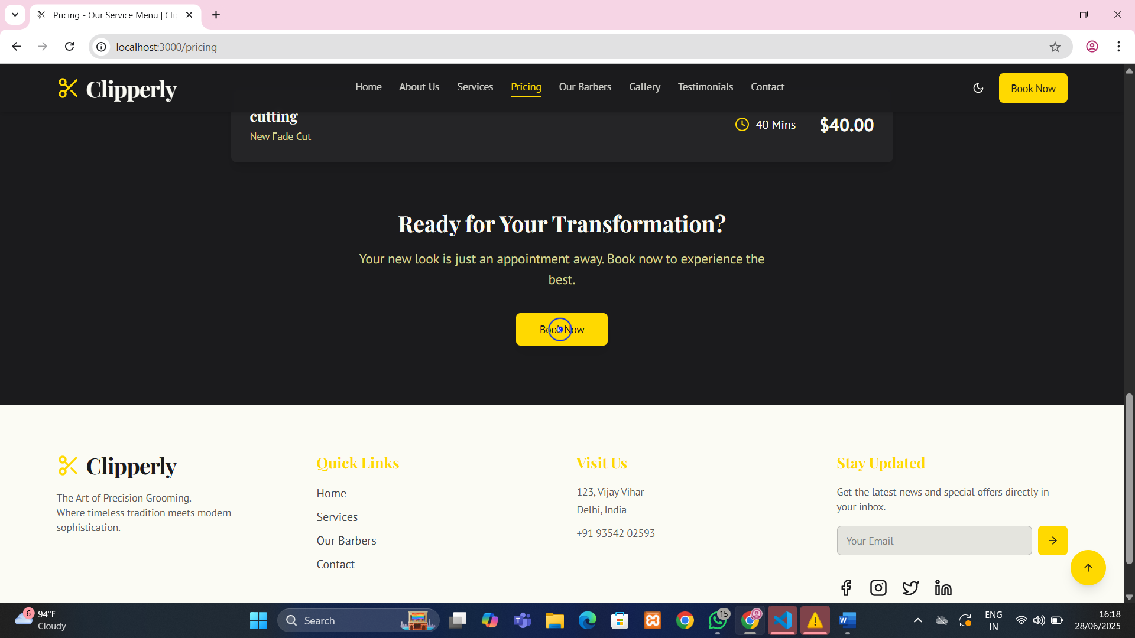

Figure 4.2: Pricing table showing service names, corresponding costs and its footer.

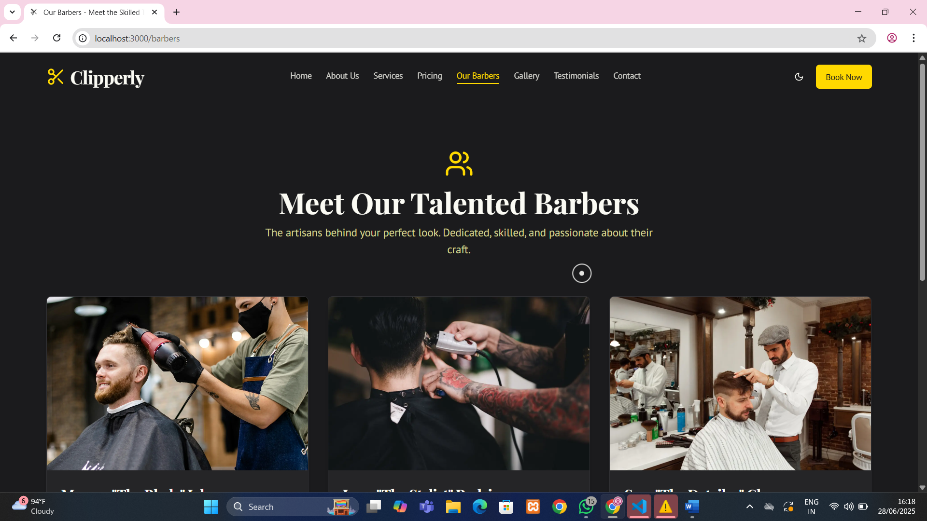

Figure 5.1: Barbers section presenting team members with specialization details.

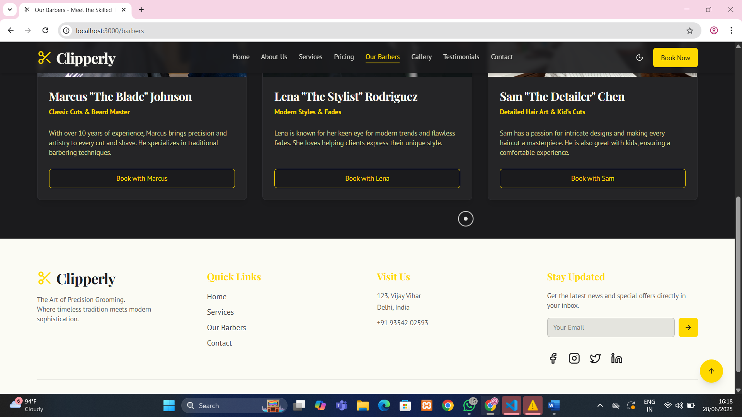

Figure 5.2: Barbers section presenting team members with specialization details and its `footer.

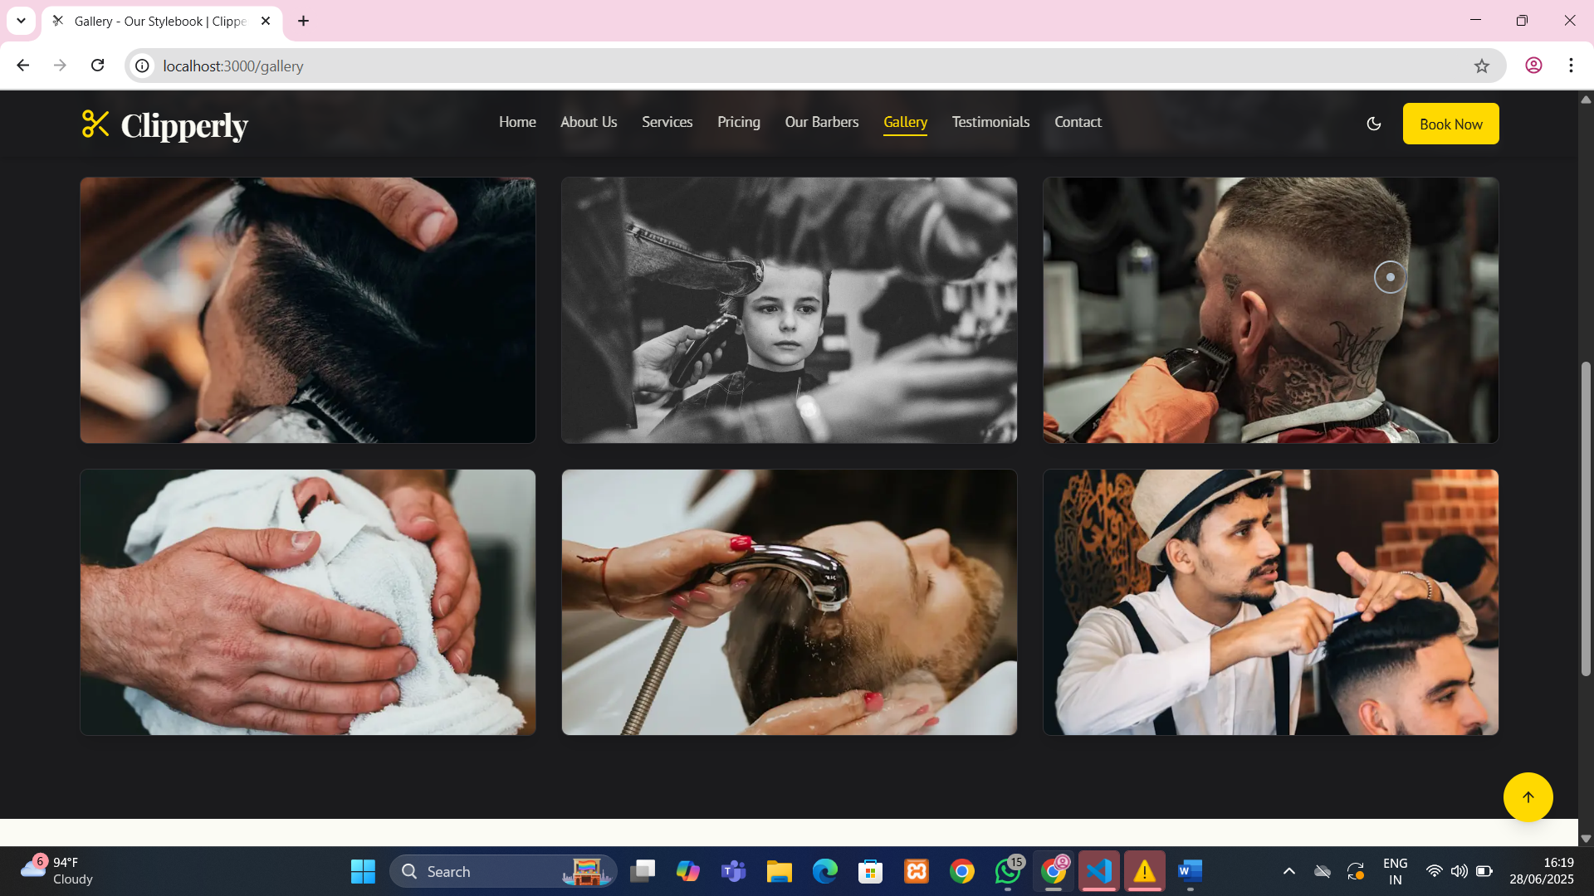

Figure 6.1: Gallery section showcasing haircut styles and shop interiors.

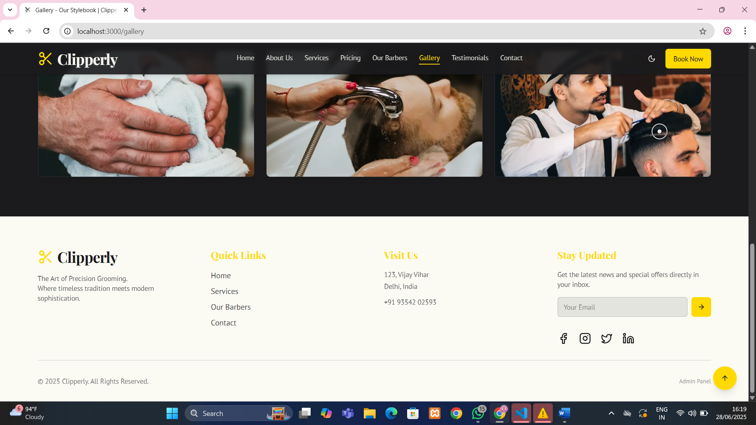

Figure 6.2: Gallery section showcasing haircut styles, shop interiors and its footer.

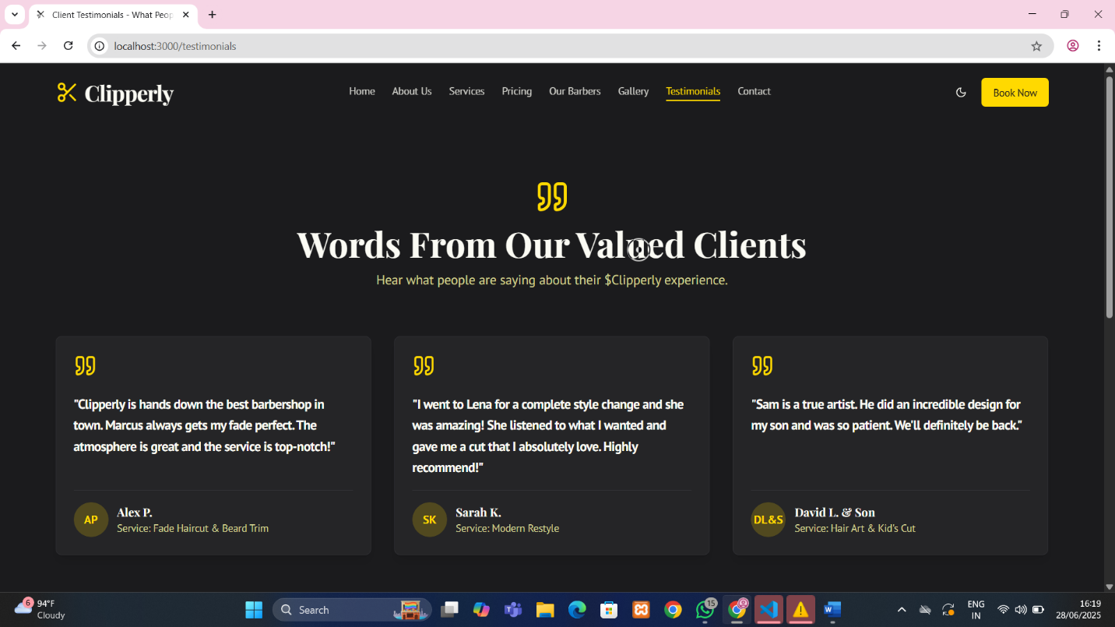

Figure 7.1: Testimonials section showing customer reviews and feedback layout.

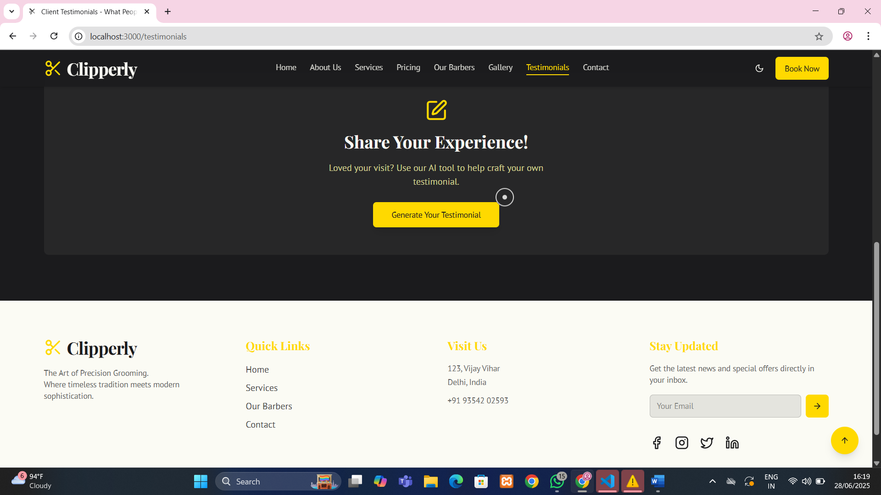

Figure 7.2: Testimonials section showing customer reviews, feedback layout and its footer.

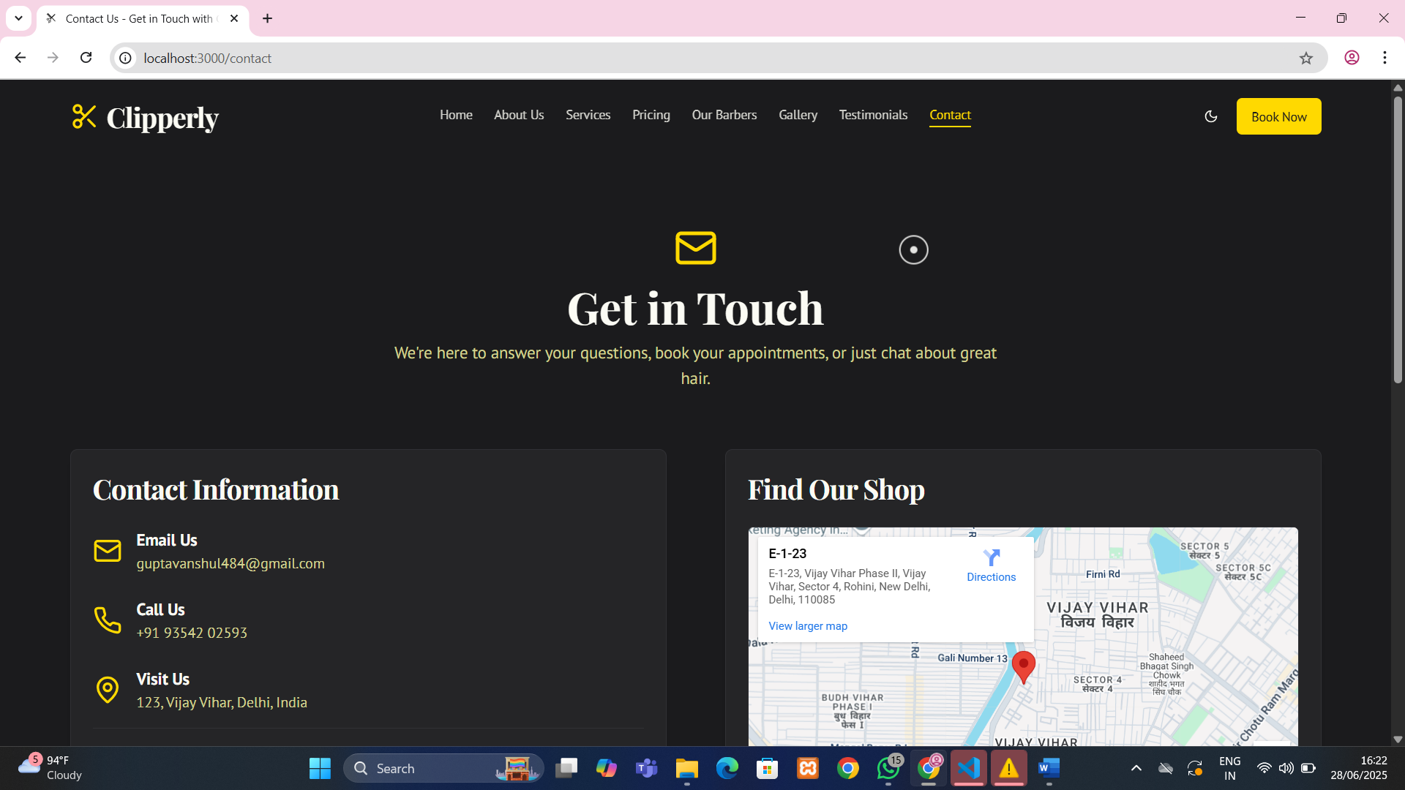

Figure 8.1: Contact/Enquiry form for users to send queries to the shop.

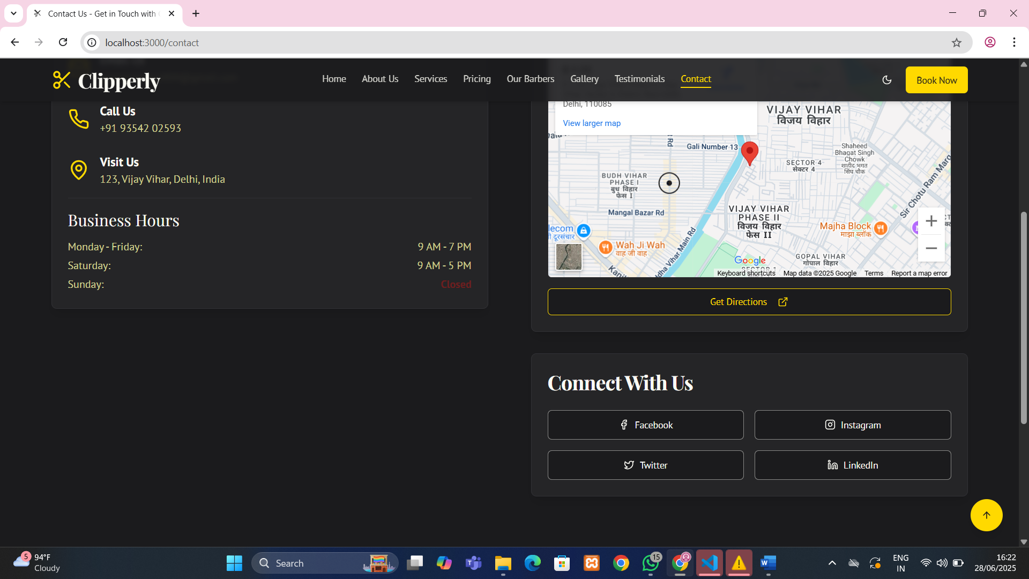

Figure 8.2: Contact/Enquiry form for users to send queries to the shop.

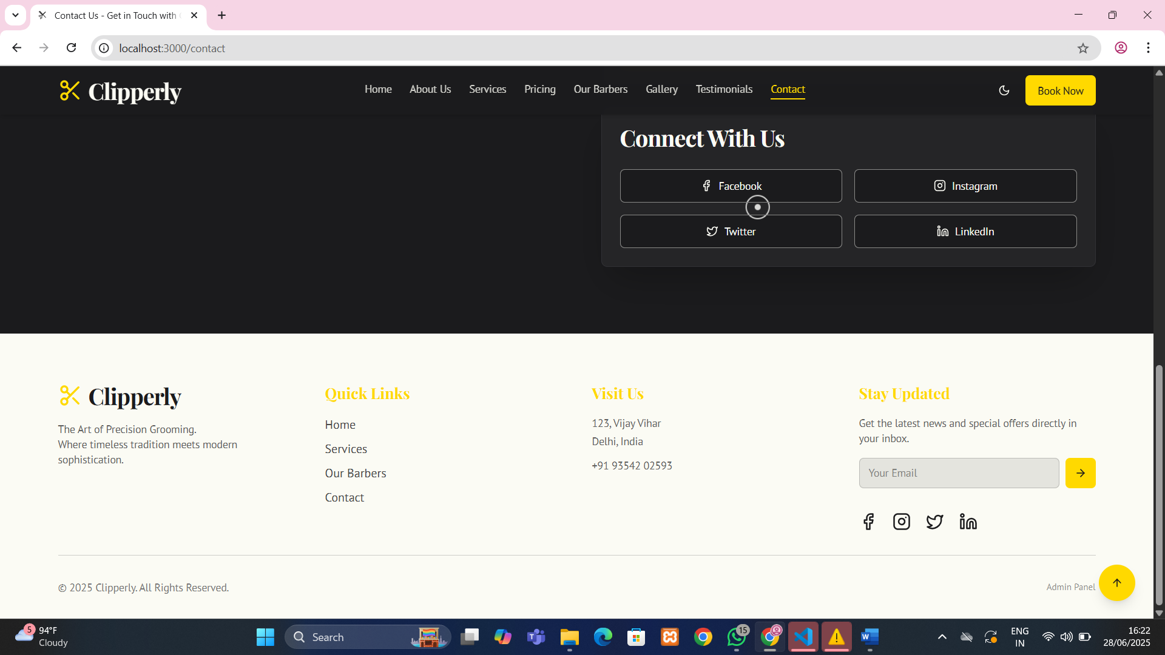

Figure 8.3: Contact/Enquiry form for users to send queries to the shop and its footer.

Figure 9.1: Enquiry management panel listing all user-submitted enquiries.

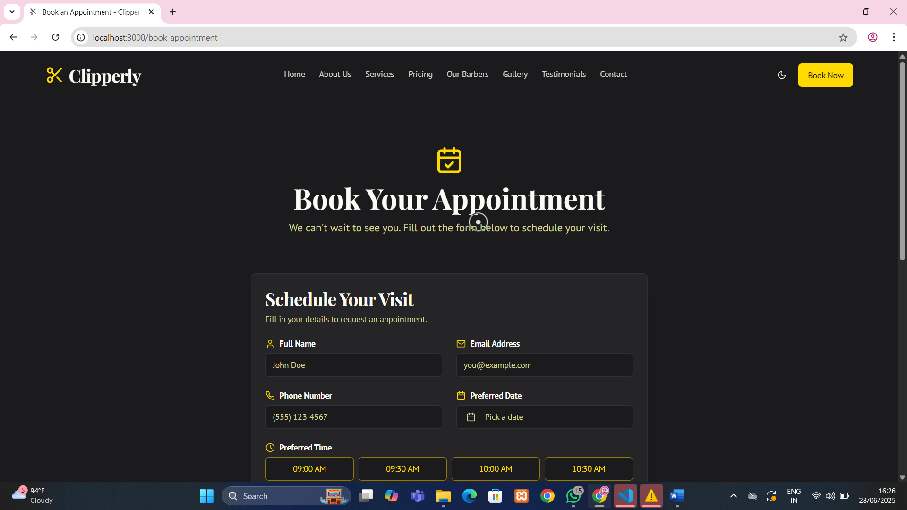

Figure 9.2: Enquiry management panel listing all user-submitted enquiries.
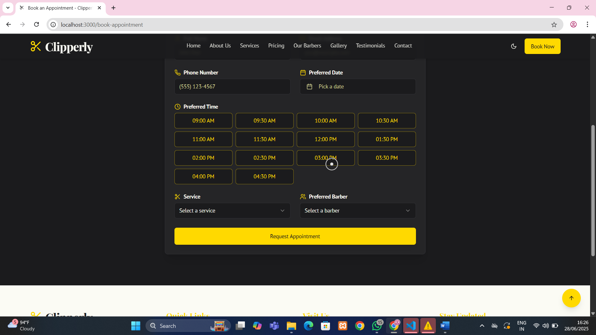

Figure 9.3: Enquiry management panel listing all user-submitted enquiries and its footer.
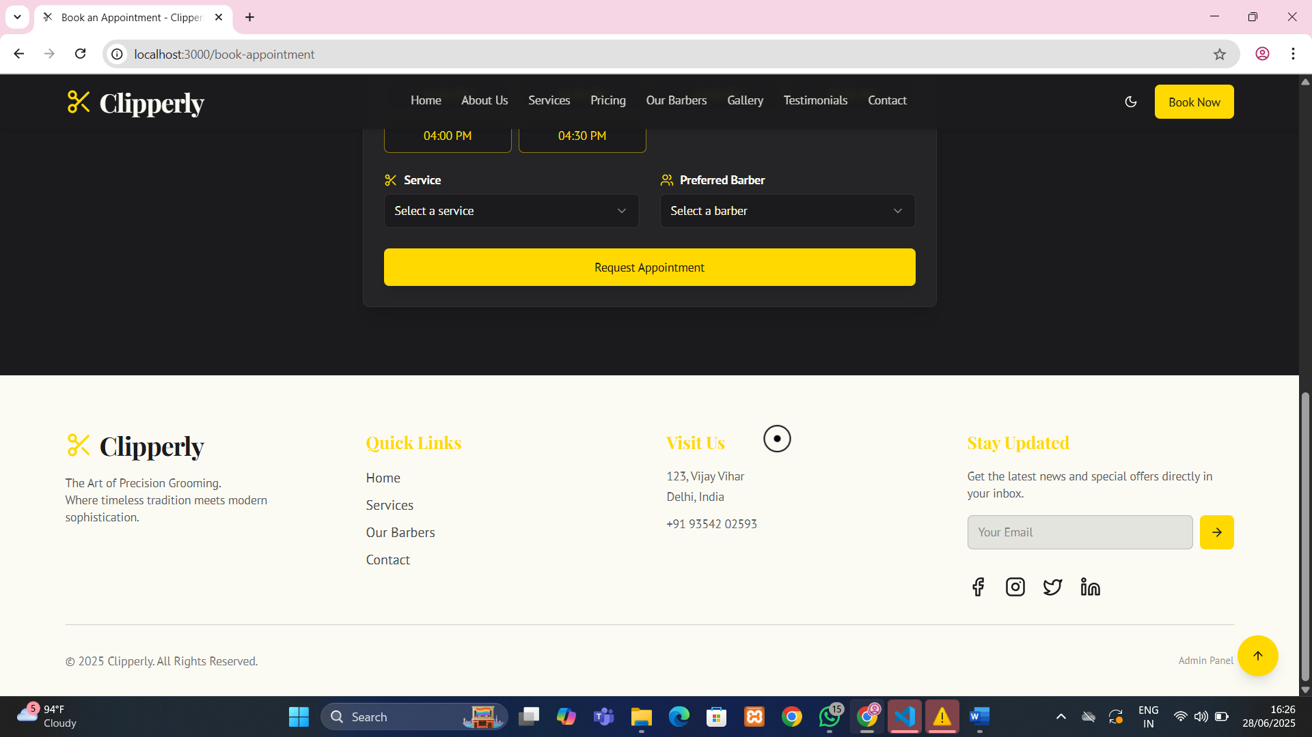

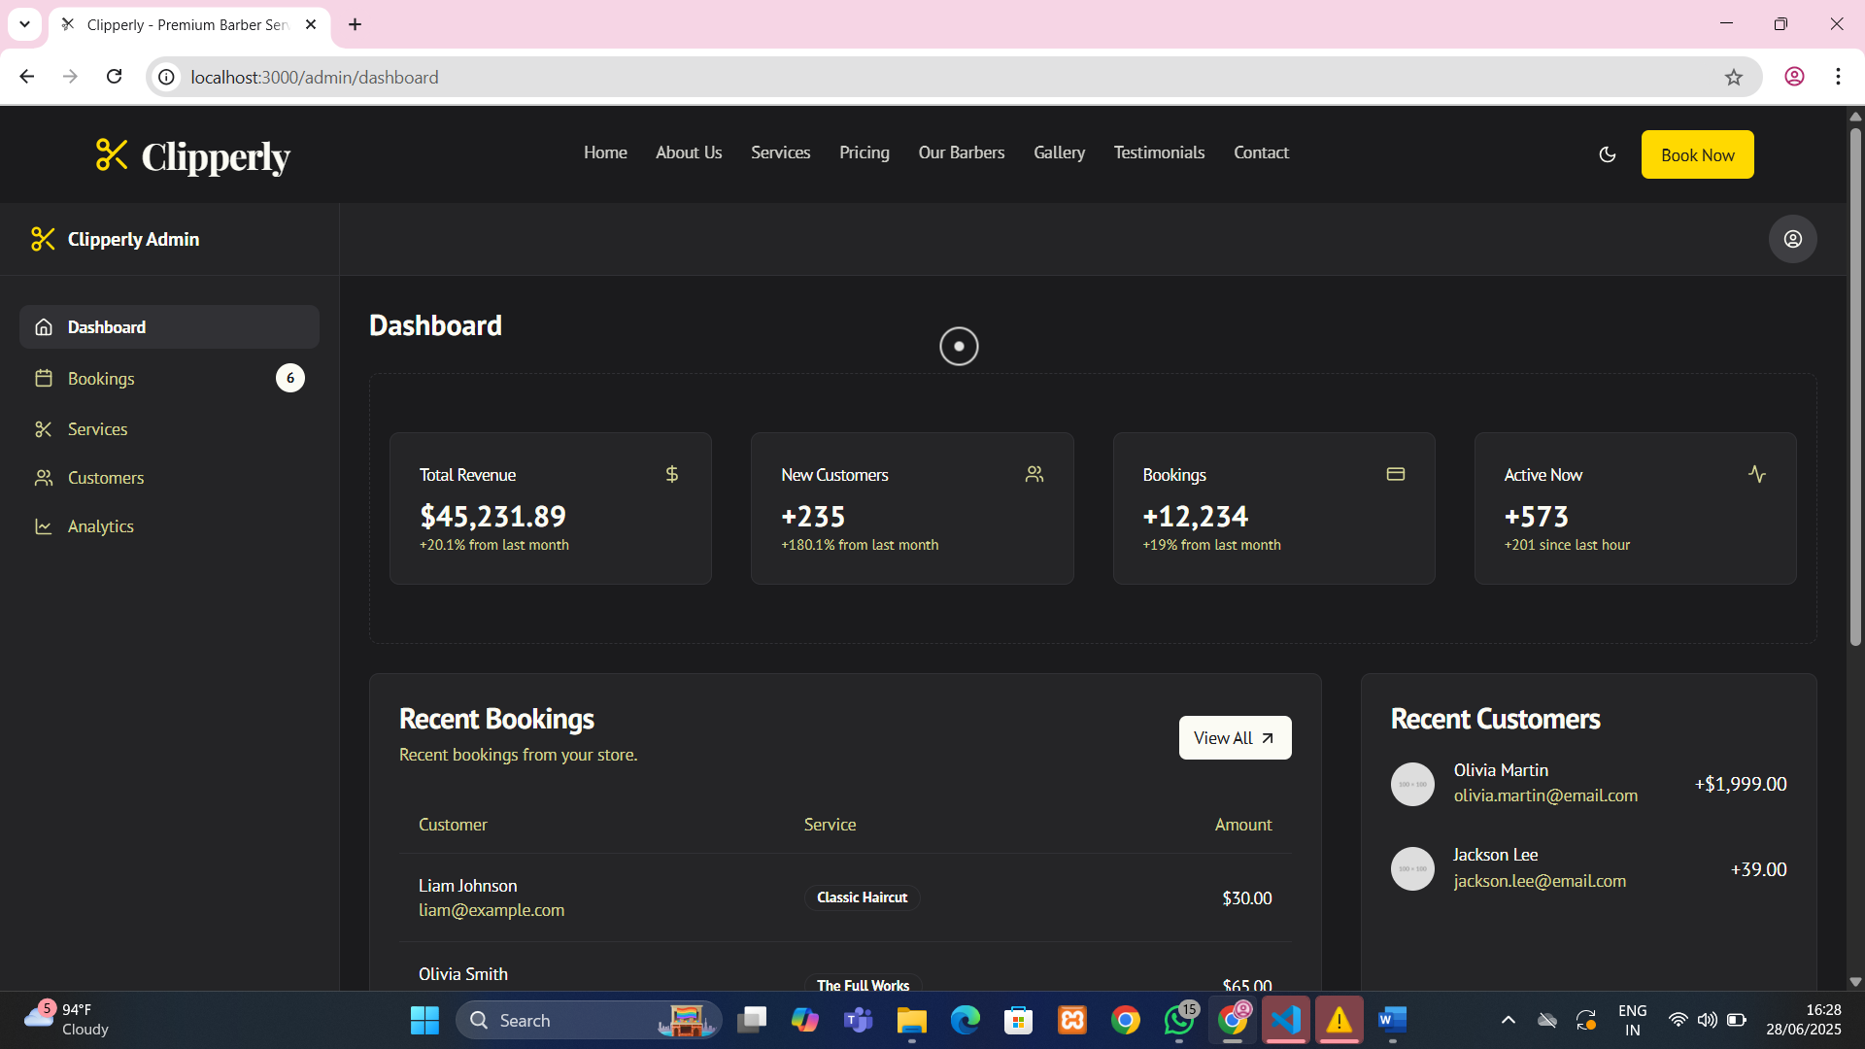

Figure 10.1: Admin dashboard overview with total enquiries, services, and testimonials.

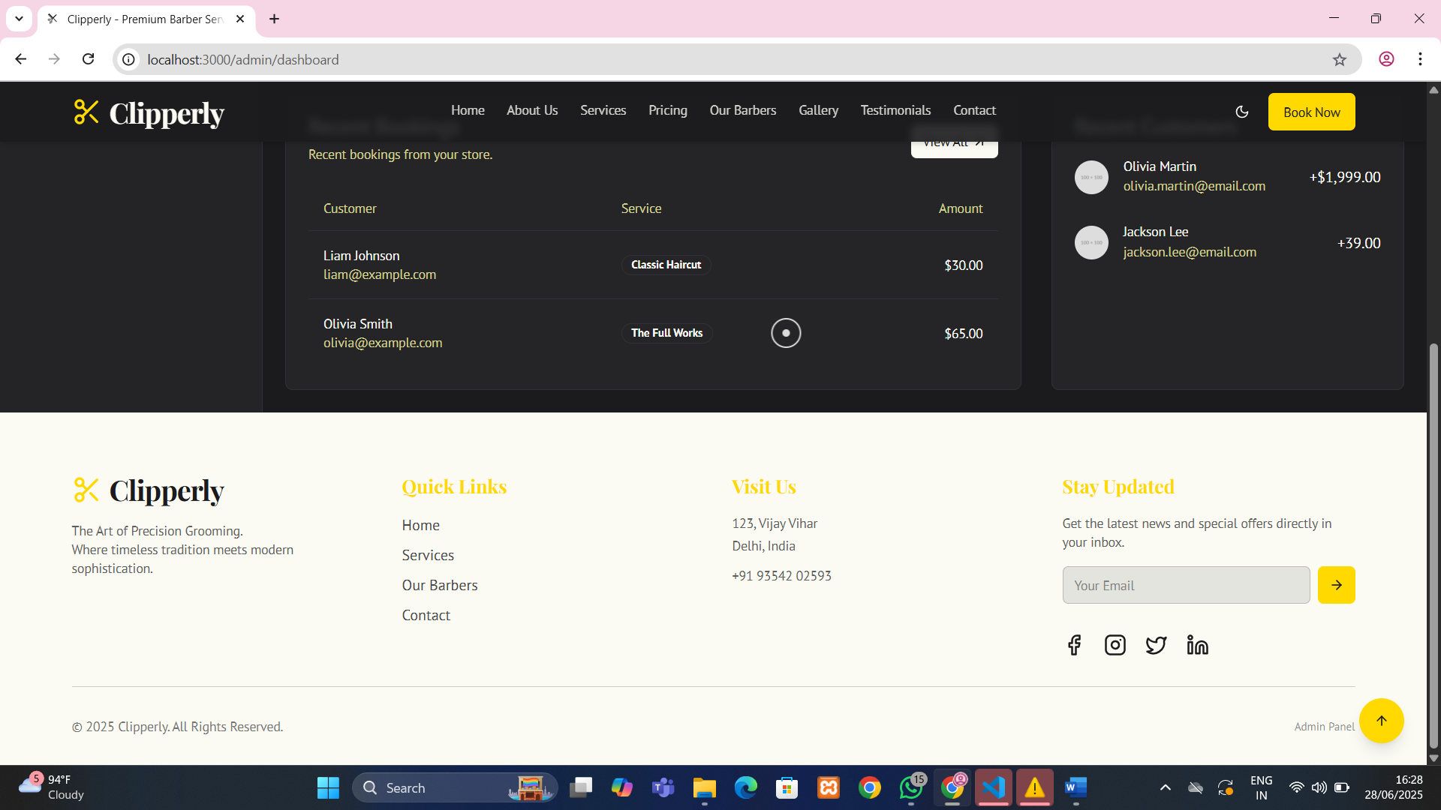

Figure 10.2: Admin dashboard overview with total enquiries, services, testimonials with footer.

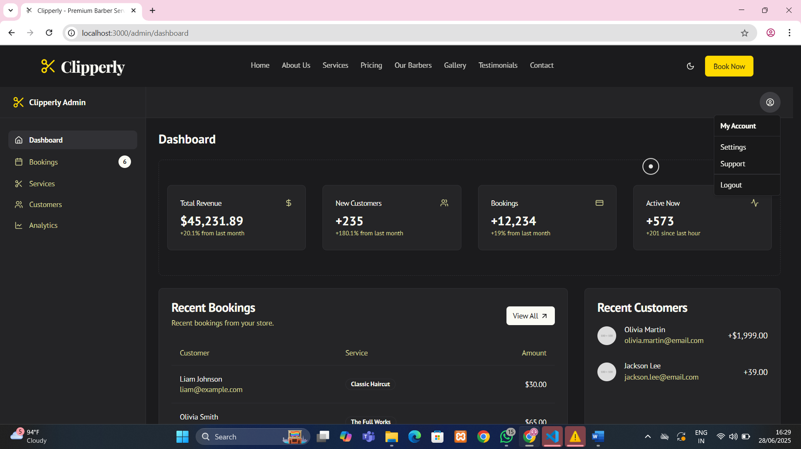

Figure 10.3: Admin dashboard overview with booking customers.
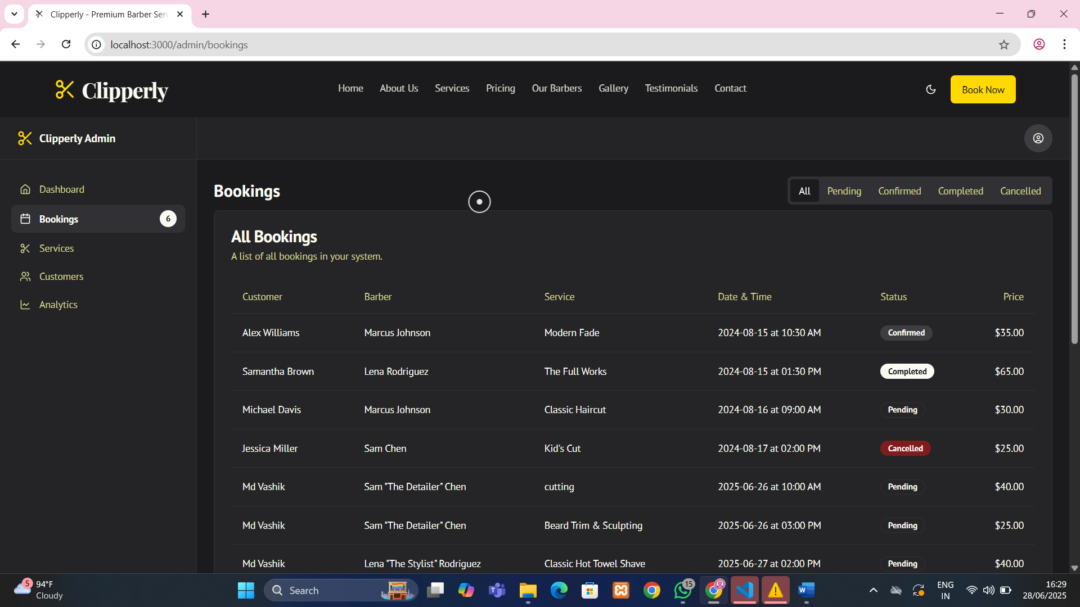

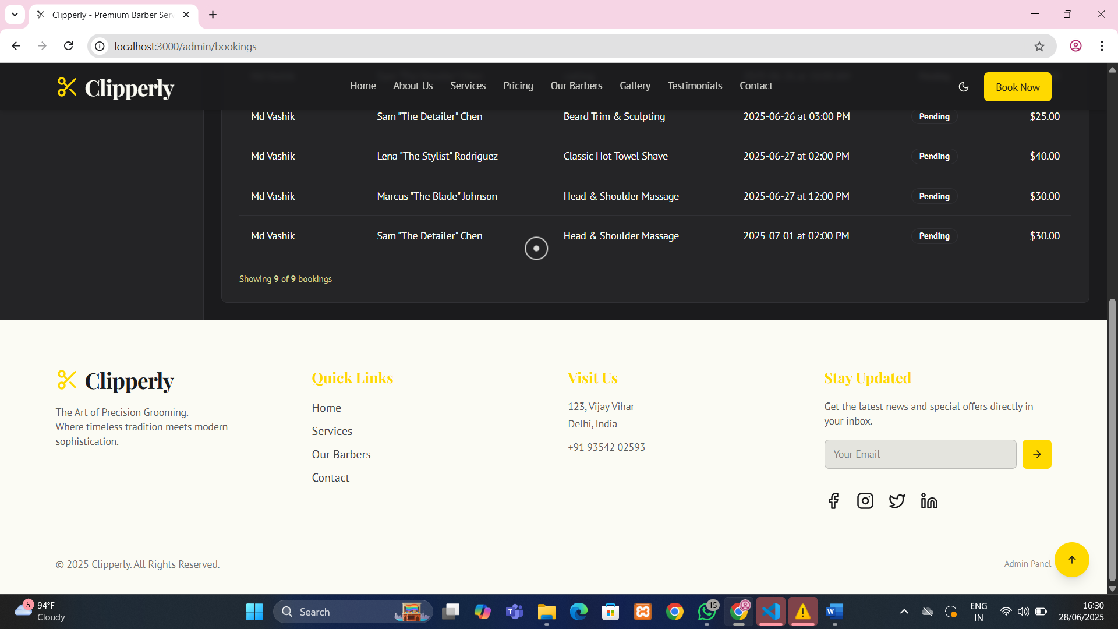
Figure 10.4: Admin dashboard overview with booking customers and footer.

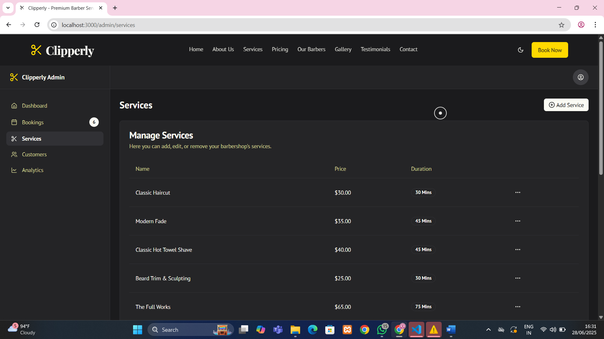

Figure 10.5: Admin dashboard overview with management services.

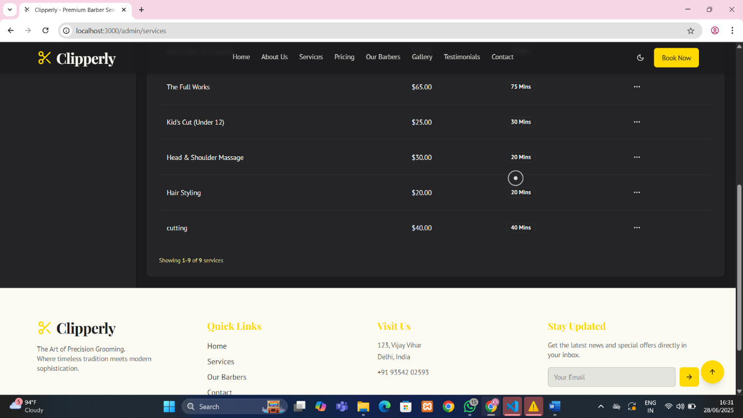

Figure 10.6: Admin dashboard overview with management services and footer.
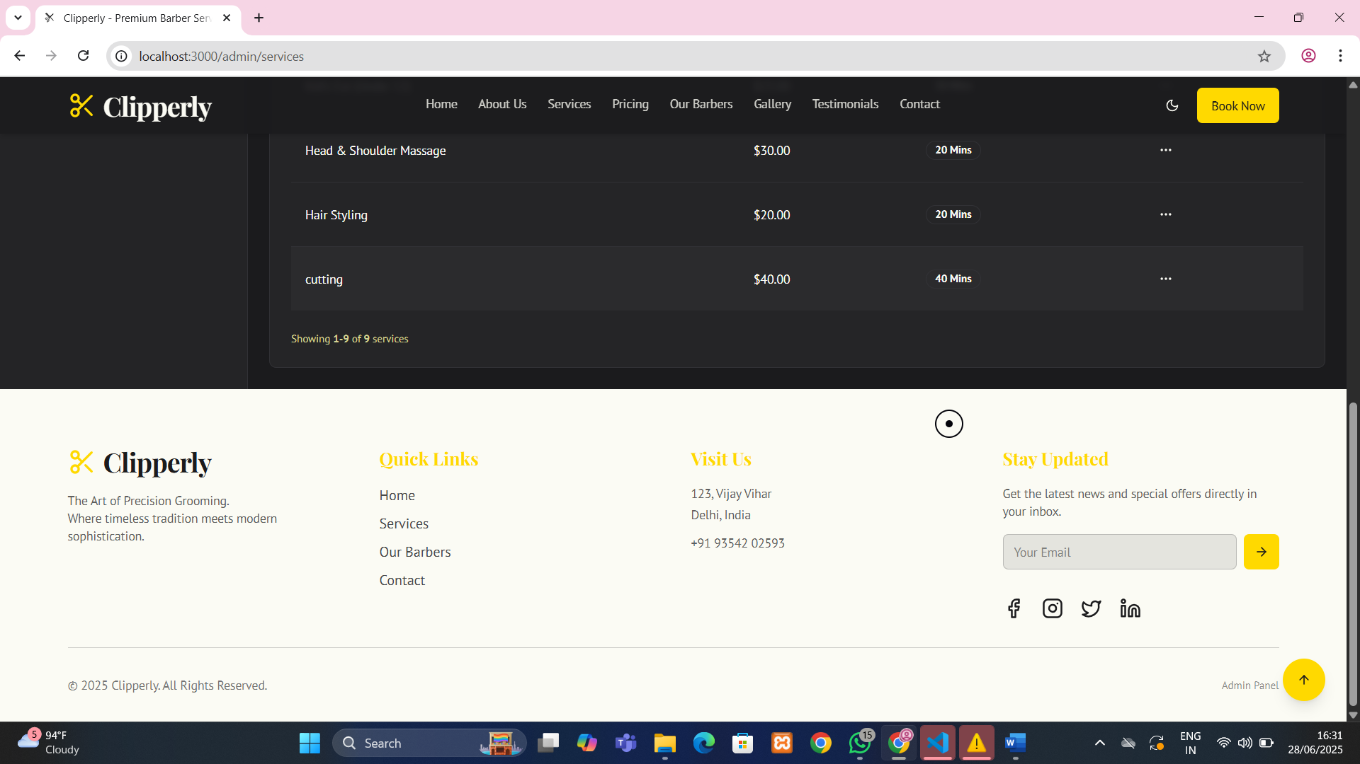

Figure 10.7: Add/Edit Service page with form and CRUD controls.
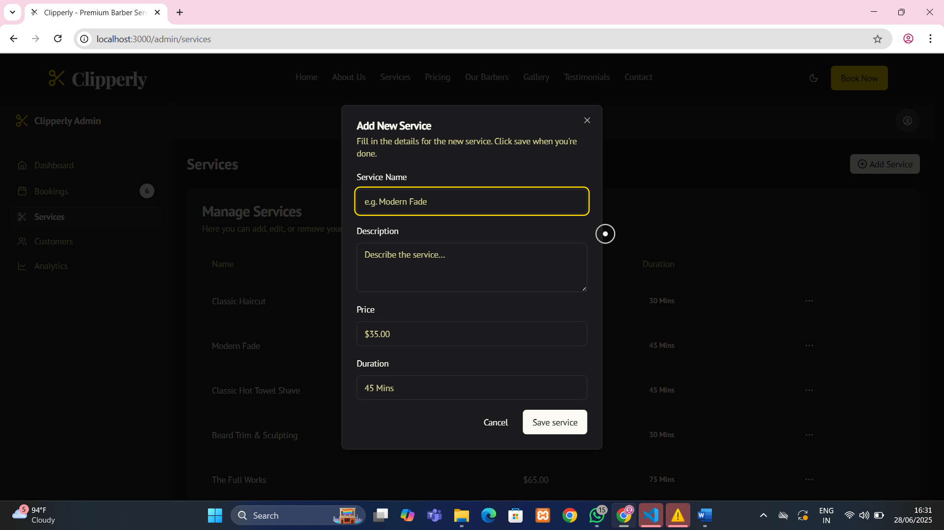

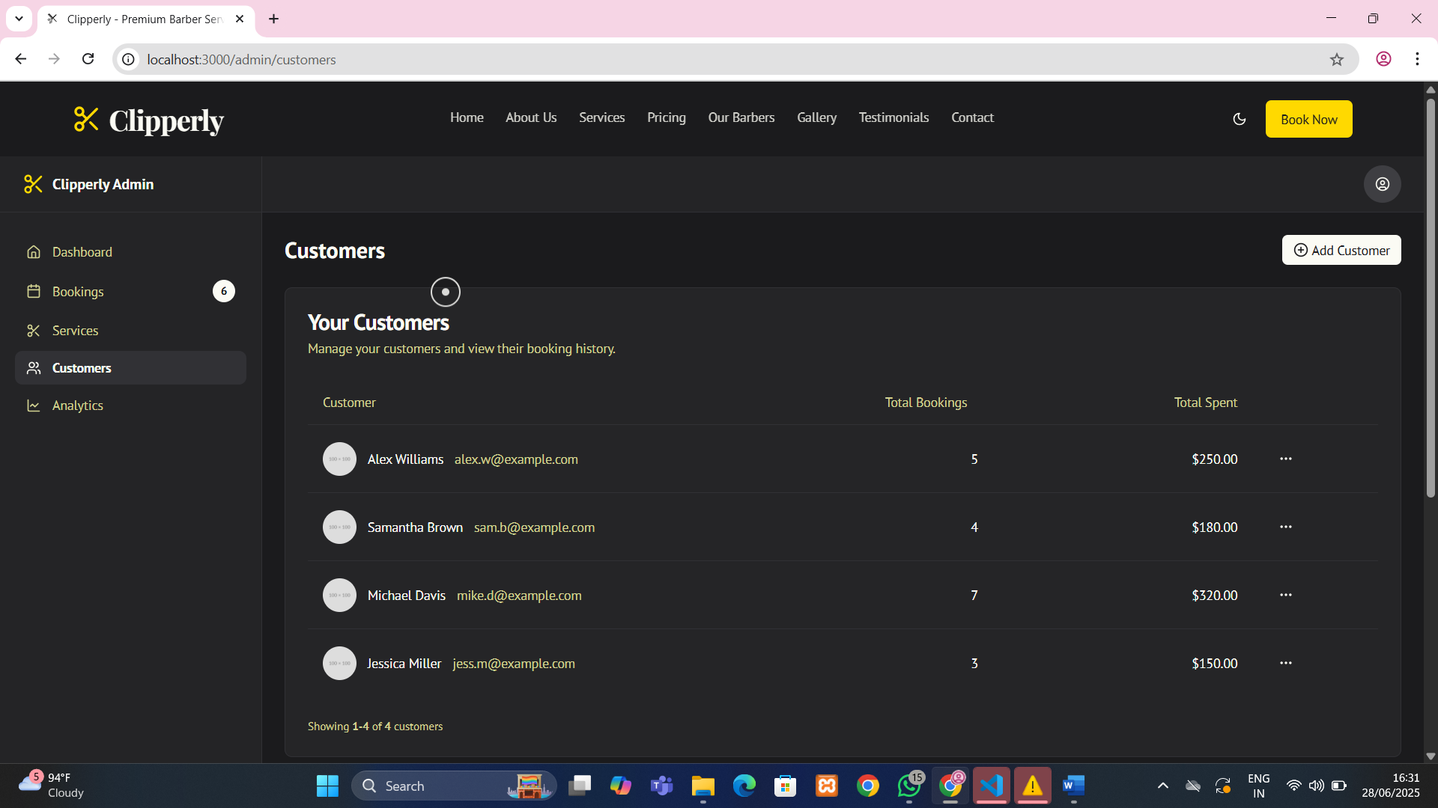

Figure 10.8: Add/Edit customer’s booking.

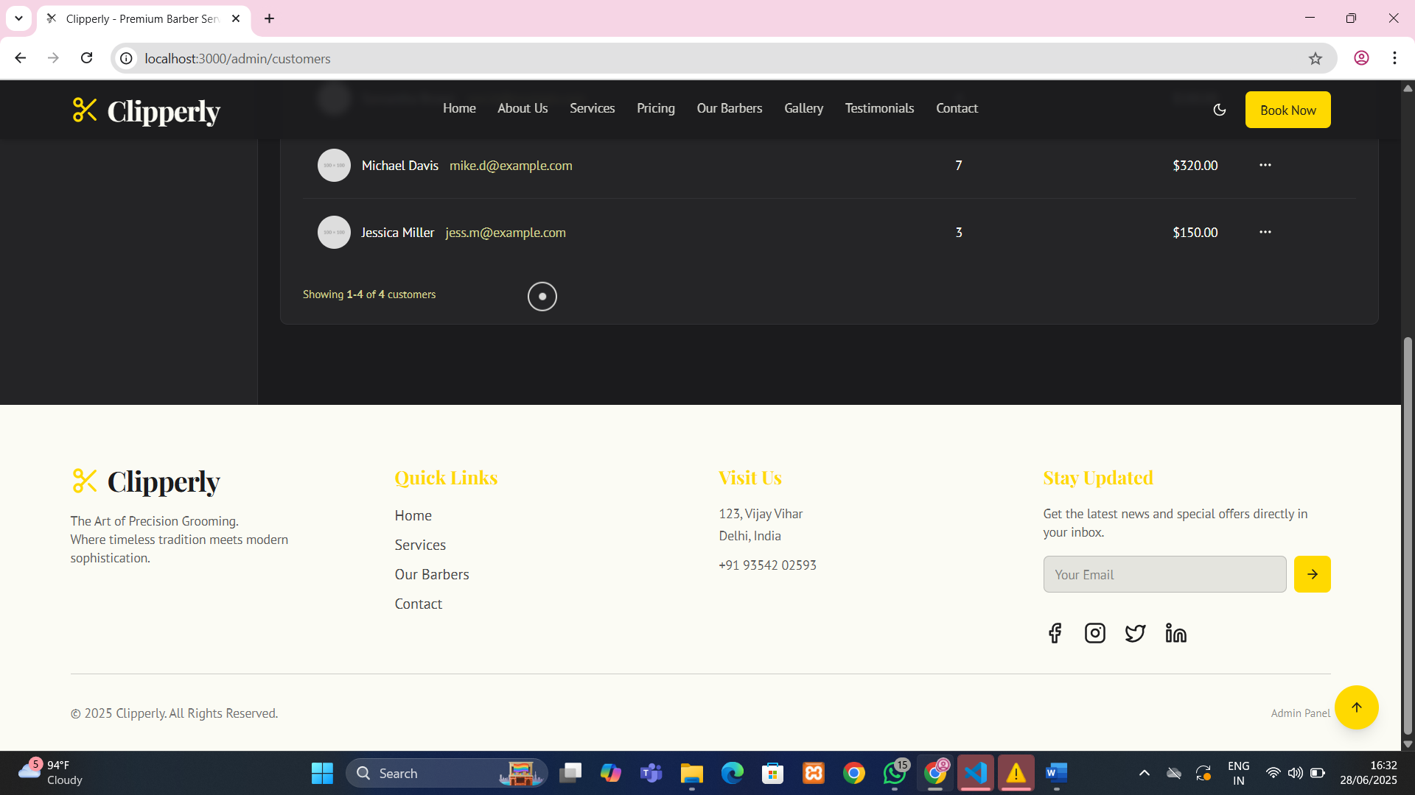

Figure 10.9: Add/Edit customer’s booking with footer.

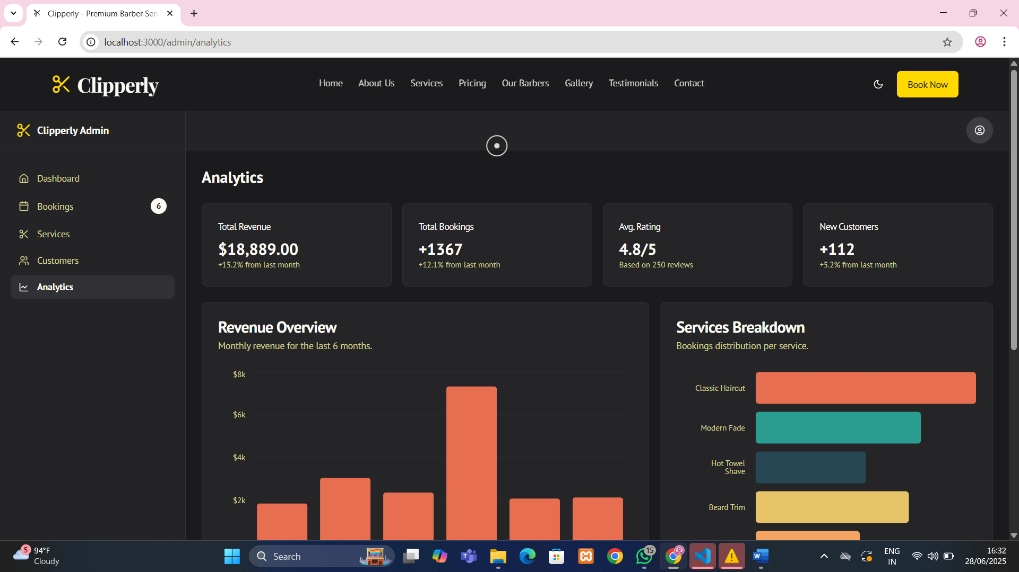

Figure 10.10: Admin dashboard overview with service analytics.

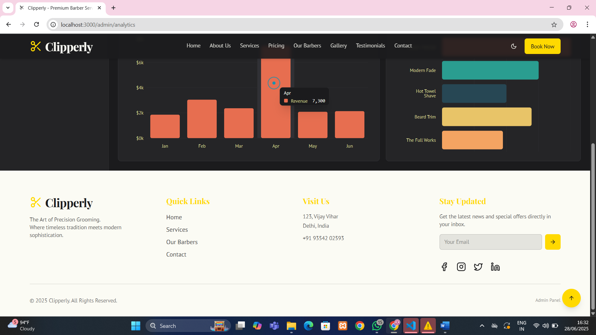

Figure 10.11: Admin dashboard overview with service analytics and footer.

15. Future Scope
The Clipperly website has significant potential for future enhancements, transforming it from a static service platform into a fully dynamic, intelligent, and scalable digital solution for the grooming industry.

In upcoming versions, an integrated appointment booking module can be introduced, allowing users to select services, barbers, and available time slots in real time. This feature can be connected to calendar syncing and SMS/email notifications to reduce no-shows and improve scheduling efficiency.

A user registration system could enable customers to create personal profiles, view their service history, manage appointments, earn loyalty points, and receive personalized offers. Moreover, integrating a payment gateway will streamline the booking-to-payment cycle, supporting methods like UPI, cards, and wallets for seamless transactions.

The platform can also evolve into a multi-branch system, where multiple barbershop branches can manage their schedules, staff, and clients under one centralized admin panel, making it suitable for franchises.

To boost customer engagement, a dynamic feedback and rating system can be added, where only verified customers can leave testimonials, along with options to rate specific barbers or services. Artificial Intelligence (AI) can be utilized to analyse customer preferences and offer personalized recommendations.

Additionally, a real-time chatbot or live support module can enhance communication between customers and the barbershop, handling queries, booking assistance, and general support. In the long term, the system can be transformed into a Software as a Service (SaaS) platform for other salons and barbershops, enabling them to use the system under their branding with minimal setup.

With these future improvements, Clipperly has the potential to scale beyond a website into a full-fledged, intelligent digital ecosystem for the grooming and salon industry
16. Bibliography & References
- Next.js Documentation
- Tailwind CSS Documentation
- Framer Motion
- MongoDB Docs
- Express.js Guide
- Firebase Authentication
- StackOverflow, GitHub Repositories, and Tutorials

